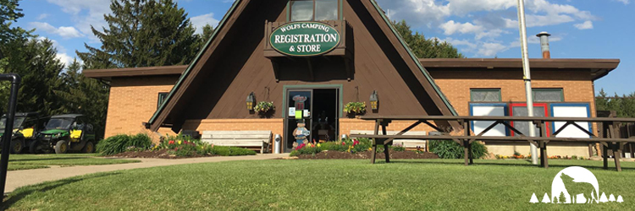
MAY BUDDY RALLY
May 8-10, 2020
Wolf’s Camping Resort
308 Timberwolf Run, Knox, PA 16232
814-797-1103
Hosts: Cody Klingler & Matt Moore
724-504-6884 or cwk5292@gmail.com

Get your Airstream ready for the first rally of the season! This years May Rally will be a buddy rally. This means that you can invite a non-Airstream travel trailer to join us for the weekend.

Please make your reservation with Wolf’s Camping Resort as they require a down payment of $25 to hold your spot. Our reservation is listed under “Al-Mon-O Airstream Club”. Please use this when you call to make your reservation. The campground fee will be $41 per night. We have reserved 10 sites close together until March 28. After this date, we can’t guarantee you’ll be parked near us. You are welcome to come early and stay late.

Once your reservation is made, please reach out to Cody or Matt to let them know which site you have. The rally fee will be $7 per person. This fee includes: breakfast Saturday morning, dinner Saturday evening and a continental breakfast Sunday morning. Please bring all drinks and table service to each meal except Friday night. Saturday nights dinner will be a potluck dinner.

Friday, May 8:
Check in starts at 4 PM.
Dinner at (to be determined) at 6 PM

Saturday, May 9:
Breakfast starts at 8:30 AM at Cody and Matt’s Airstream
Lunch on your own
Wine excursion to Deer Creek Winery at 1 PM (3333 Soap Fat Rd., Shippenville, PA 16254). We can carpool if needed
Happy hour at 4 PM
Potluck Dinner at 6 PM with campfire to follow (weather permitting)

Sunday, May 10:
Continental breakfast begins at 8:30 AM
Check out by 3 PM

