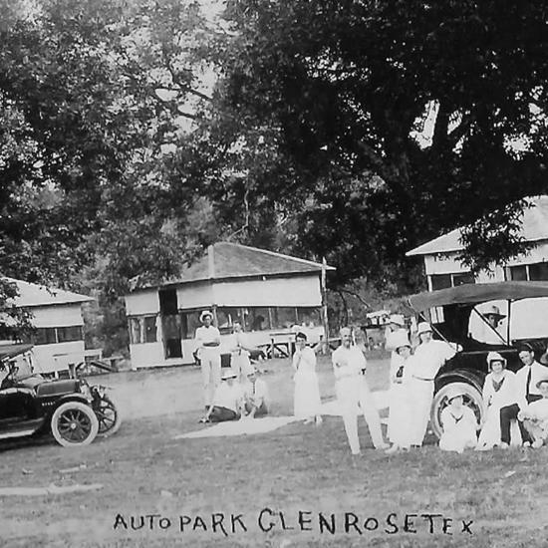
TEXAS HILL COUNTRY UNIT 104
NOVEMBER 11-15 AIRSTREAM & BUDDY RALLY
OAKDALE RV RESORT & MOTOR COURT
AT
OAKDALE PARK, GLEN ROSE
1019 NE Barnard St., Glen Rose, Texas 76043
(Only Private Texas RV Park on the National Register of Historic Places)

Wednesday Nov 11
3-5:00 p.m. Arrive
5:30 p.m. Official Welcome - Fire Ring*

Thursday Nov 12
10:00 a.m. Fossil Rim Wildlife Named best Wildlife Safari in USA
(Pre-Purchased Tickets Required Friday Morning $30 a person)
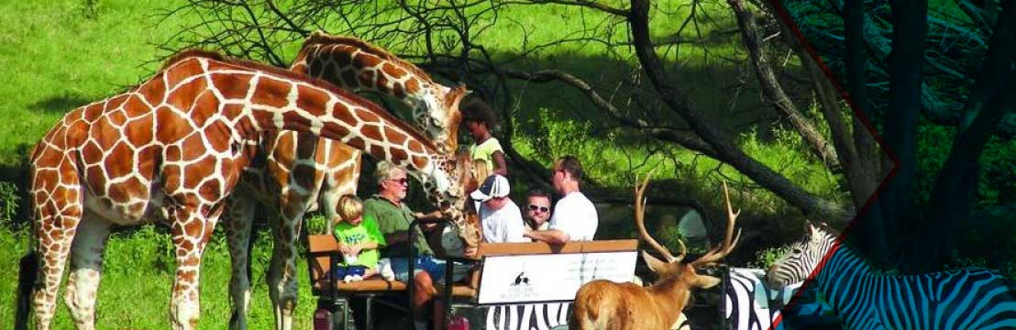
Noon Lunch on Your Own
1 p.m.-5 p.m. Explore Historic Glen Rose on Your Own
5:30 p.m. Social- Fire Ring*

Friday Nov 13
9:00 a.m. Dinosaur Valley State Park 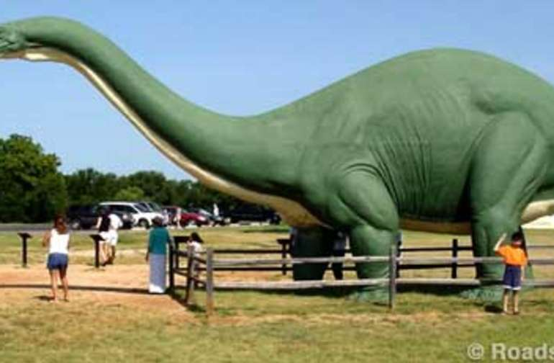
(Admission $7.00 per person)
Noon Lunch on Your Own
2:00 p.m. Private Tour of Barnard Mill and Art Museum (Donation)
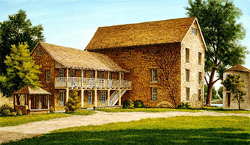

3-5 p.m. Gypsy Market (Optional)
5:30 p.m. Beer and Wine Down- Fire Ring*
Entertainment
7:00 p.m. Wine Tasting and Entertainment at Bull Lion Tasting Room Downtown GR

Saturday Nov. 14
11:30 a.m. Somervell History Museum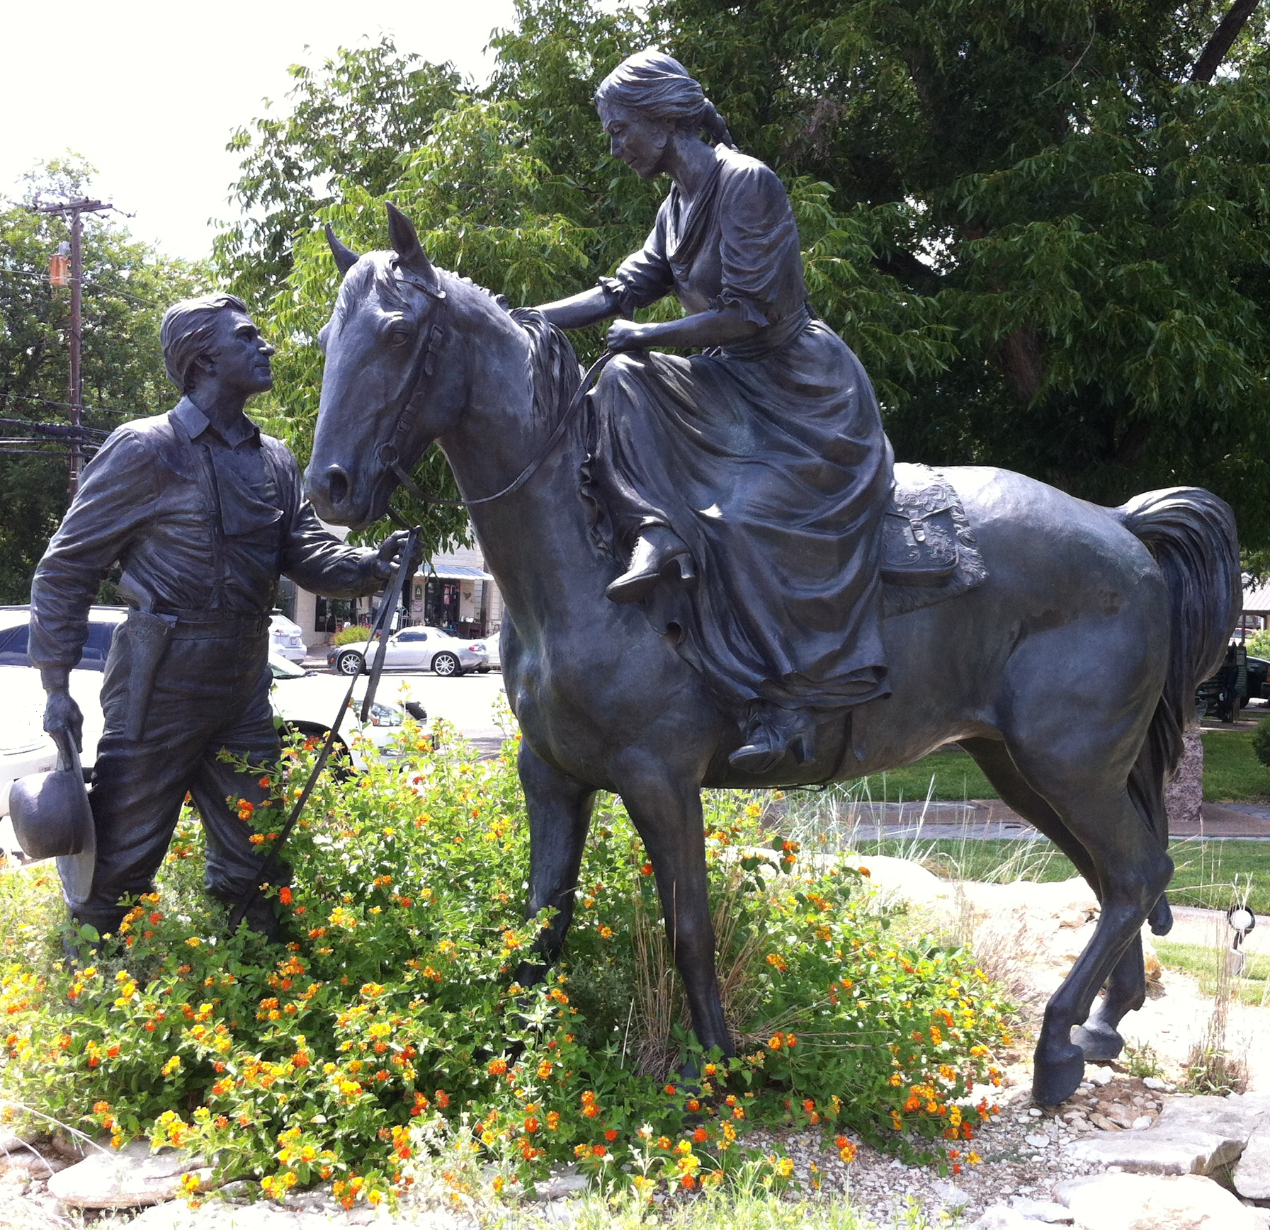
Noon Lunch on Your Own
1 p.m.-4:00 p.m. Fun and Games- Oakdale Casino
4:00 p.m. Social Hour- Oakdale Casino
5:30 p.m. Bring an Entre and sides, grilling provided
7:30 p.m. Installation of Officers-Oakdale Casino

Sunday Nov. 15
8:30 Devotional
9:00 – 11 a.m. Depart for Home

