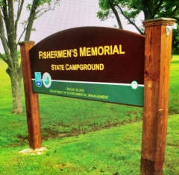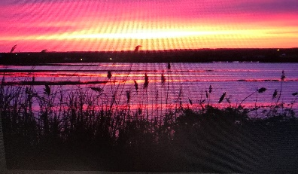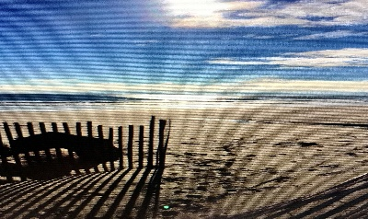
Join us at Fishermen’s Memorial State Park For Springstream
Friday May 13 – Sunday May 15, 2022
1011 Point Judith Rd Narragansett, RI 02882
Fishermen’s is located close to the coastal line of Point Judith and is nestled amidst beautiful beaches like Scarborough, Salty Brine and Roger Wheeler beaches. The park is set on an area that was used by the former coastal defense Fort Greene. Newport is 30 minutes away,
Friday : check in at 1pm
6pm: Happy Dinner (Heavy Appetizers) followed by an evening campfire
Saturday: 8am Pot Luck Breakfast, juice and coffee provided
Enjoy the area beaches, take the ferry to Block Island or just enjoy the campground.
5pm: Happy Hour, then dinner on your own, wonderful seafood restaurants nearby
Evening campfire and good fellowship
Sunday: 8am: Continental Breakfast with coffee and juice provided. Check out at 11am.
Reserve your own site through Reserve America. Note these sites go fast. We are in site 064.
Rally fee $10 per trailer for food and firewood : $8 for one person
Hosts : Bonnie Hogan and Greg Desnoyers
Name(s)__________________________ WBCCI#________
Address__________________________________ Adults___ Children___
Email________________________________ Cellphone______________
Please make out checks for rally fee to Bonnie Hogan & mail to 56 Carr Lane Jamestown, RI 02835

