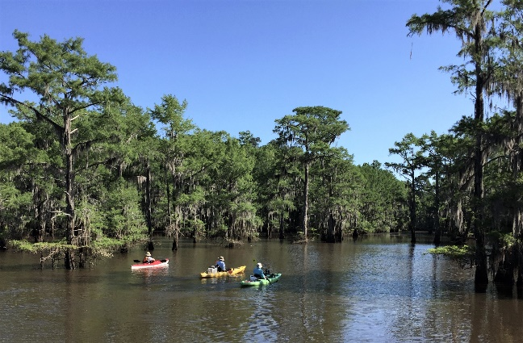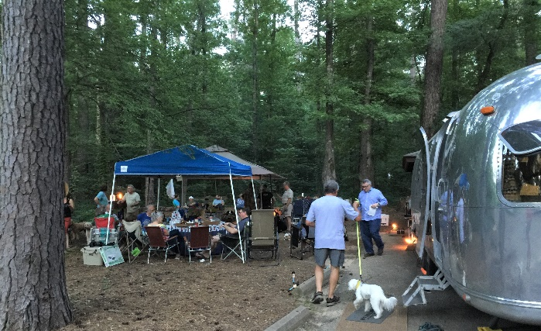
Join HOTC for a great time at Caddo Lake State Park in the Big Cypress Bayou, a waterway into Caddo Lake! The bayou is filled with large old cypress trees with overhanging Spanish moss, creating a beautiful and somewhat mystical scene. At Caddo Lake State Park, you can fish, paddle, & hike. Explore Caddo Lake’s twists and turns. Rent a canoe in the park or bring your own canoe or kayak. You can also venture onto more than 50 miles of paddling trails in the Caddo Lake area. There is a boat ramp for fishing boats. Alligators do live in these waters but we have yet to see one in our 4 trips here so far; just be aware.
Schedule of Events (tentative)
All meals, bring your own set-ups (utensils, plates, napkins, drinks) and chairs
For those coming early on Thursday: Meet at Jim & Debi’s site 15 for after dinner drinks and snacks with campfire around 6PM.
Friday: If you arrive early enough, you may want to go into historic Jefferson to look around town at their historic sites, shop and have lunch.
5PM meet & greet at site 15 for a Margarita happy hour and bring your favorite hors d’oeuvres around a campfire. (Margaritas provided)
Saturday: 8AM -9:30AM Site 15, Early-risers breakfast on the griddle with bacon, sausage, eggs, & coffee. Bring whatever else you may want to share.
10:00AM meet to drive to the old abandoned Army Ammunition plant nearby, (tentatively) led by John Coppedge. Very interesting history here and see old abandoned buildings overgrown with moss, brush & trees. Great Photography opportunity!
1PM- Those with kayaks, canoes, join us for a paddle tour. We’ll follow one of the paddle trails to see the bayou. It will take at least a couple of hours to do the trails at a leisurely pace.
There are also commercial boat tours available: Captain Ron’s Swamp Tours is the closest to the State Park, boarding at Big Pines Lodge & Restaurant, Karnack, TX. Captain Ron’s number is 903 679-3020.
OR, if boating isn’t your thing, take a 13-mile drive into Jefferson to enjoy the historic town.

5-6PM Happy Hour at the Rich’s site 15. 6PM will start dinner. The Rich’s will be frying chicken strips served with various dips. Bring your favorite side dish or use the grill to cook your own meat.
Sunday: 8AM-10AM Farewell Coffee & Pastries at site 15
Happy Trails to you, ‘til we meet again!
Your Rally Hosts: Jim & Debi Rich
Additional info: The campground is heavily wooded, sites are a good ways apart, and our site 15 is sort of in the middle. You may want to bring a wagon or cart to haul your chairs, etc. back and forth, especially if you are parked in sites 26-36. Also, there is a parking lot for about 5 vehicles across from site 15. If you have access to firewood, please bring some for our campfires. Any further questions email me at divadebi@swbell.net or if you need to call, our numbers are: Debi 405 650-0235 Jim 405 650-7113

