**Outdoor Mystic Art Festival Rally**

**August 12-15, 2022**

**neAC-SPonsored rally**

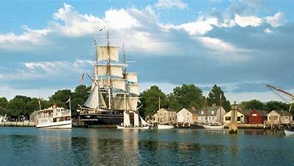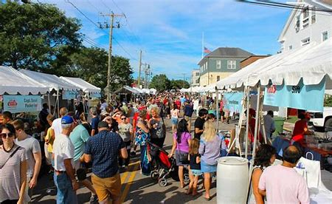

Location: **Sun Outdoors Mystic RV Resort and Campground**

45 Camp Ground Rd., Old Mystic, CT 06372

<https://www.sunoutdoors.com/connecticut/sun-outdoors-mystic>

Rally schedule:

* Friday 4:30 pm BYOB happy hour with heavy appetizer potluck
* Sat 7:30 am coffee and hot beverages, 8:30 am full breakfast will be served (bring your own set up)
* The Mystic Outdoor Art Festival Saturday 10 am – 6 pm, and Sunday, 10 am – 5 pm
* Sat pm dinner on your own at one of the many wonderful restaurants in and around downtown Mystic, then gather around the bonfire starting at 7 pm
* Sun 8 am, coffee, hot beverages, and products from local bakeries.
* Sun pm, for those staying overnight, a group dinner at a local restaurant is likely – details tbd

Information about the art festival, including map: [Greater Mystic Chamber of Commerce - Mystic Outdoor Art Festival (google.com)](https://sites.google.com/mysticchamber.org/home/mystic-events/mystic-outdoor-art-festival) . Also, lots to see and do while in Mystic, CT! Seaport, Aquarium, kayaking, bicycling, hiking trails, pool at the campground, restaurants, shopping, microbreweries, wineries, and more!

**To reserve your RV site, *CALL the campground DIRECTLY at (860) 536-4044* and mention you are part of the Airstream Club Rally.** For this rally, reservation of sites is on-your-own, and they will honor a 20% discount off listed rates between August 12-15, 2022 for our rally attendees. Twenty campsites (15 pull through and 5 back in) are being held for this rally until **April 15th**, after which time they become open the public and you can take a chance getting one.

Map of sites: <https://www.sunoutdoors.com/resourcefiles/resortmapimages/seaport-spo-site-map.jpg>

A **$5 per adult** kitty fee will be collected **upon arrival** as your contribution to one full breakfast, morning beverages each day, local bakery pastries/donuts on Sunday am, firewood, and ice for happy hour beverages.

Rally registration: As soon as you have reserved your site, please send Tess an email with your name(s), mobile phone #, site #, BigRedNumber, and days you are staying.

Questions? **Tess McShane at (860) 536-4113,** [**suzzypoi@gmail.com**](mailto:suzzypoi@gmail.com)