Michigan Airstream Club *MAC* Club Rally
August 17 – 22, 2022
Bay City State Park, 3582 State Park Dr. Bay City, MI
Sun, water, sand, bike trails, birds, campfires, music, Ranger program, games, friendship & FOOD!
Explore Tobico Marsh which just happens to be the largest Marsh in the state of Michigan
You can make your reservations after Feb 17th at: MiDNRReservations.com or call 800-44-PARKS. Snooze you lose! We have rented shelter #3 for our stay, pick a site nearby. Check your BRN & see what day you bring hors dours to Happy Hour

check
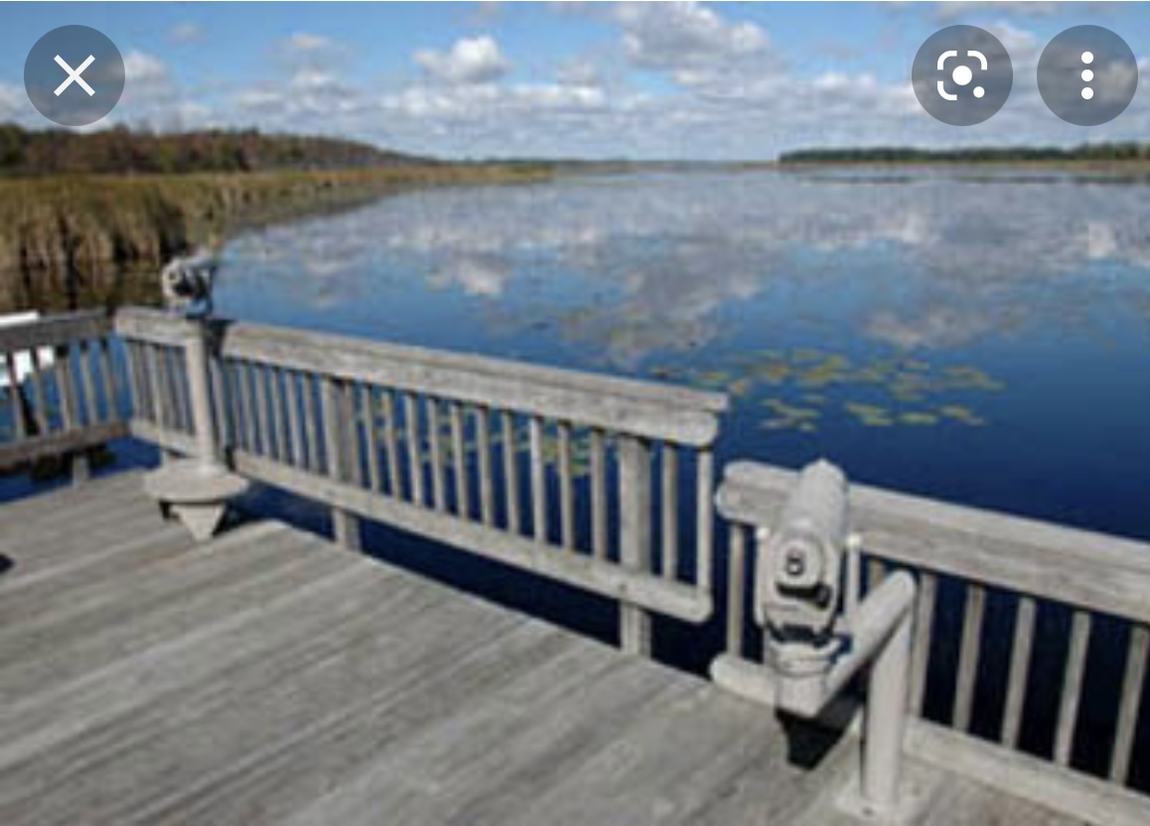
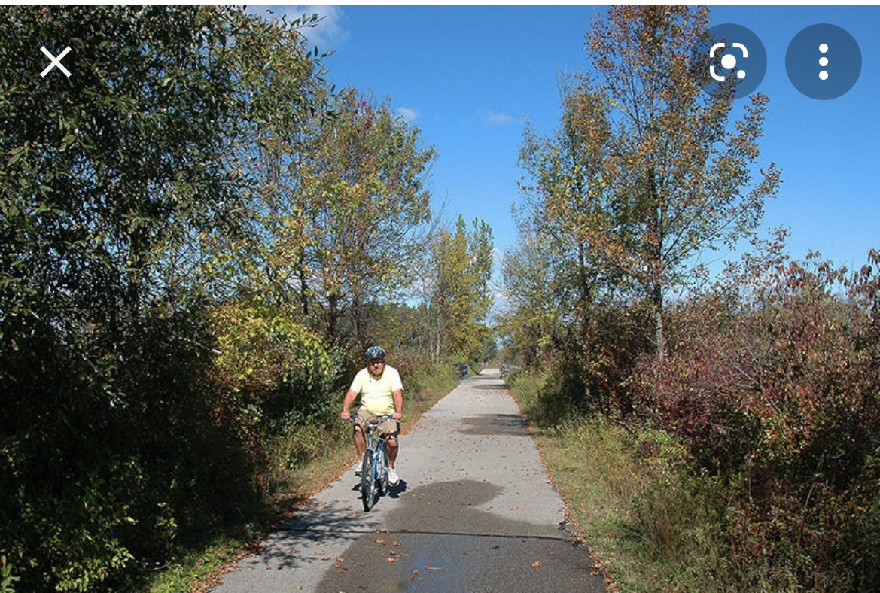

Wednesday - Arrive & Setup. Happy Hour, odd BRN numbers. A Welcome Dinner will be provided.
Thursday – AM coffee. Explore the area. Lunch will be on your own. Happy Hour, even BRN numbers. GAME night! You will not want to miss out on JEOPARDY! Enjoy a campfire & a snack.
Friday – AM coffee. Group Bike Ride or stroll, walk the dogs, together, or not. Lunch on your own. Optional self-pay tour in the afternoon, plan is dependent on Covid. Happy Hour. Dinner is provided. Ranger Program after dinner, followed by Campfire & a snack.
Saturday - AM coffee. Group Bike Ride (different trail) or stroll, walk the dogs, together, or not. Optional self-pay tour in the afternoon, plan is dependent on Covid. Happy Hour, even BRN numbers. Dinner – Bring your ‘Meat to Burn’ & a side to share. Then it’s time for some Musica, Musica, Musica, followed by a campfire & snack.
Sunday - Breakfast in Bed, Almost! Roll your butt out the door cuz ‘Jim C’ will be serving up a pancake breakfast you won’t want to miss. Some will be leaving today so Lunch is on your own. Happy Hour, odd numbers. Dinner will be ‘gotta go’ that’s Airstream lingo for leftovers.
Monday - Coffee at Lee & Jackie’s trailer. Adios, Safe travels & see you down the road!.
- - - - - - - - - - - - - - - - - - - - - -COUPON - - - - - - - - - - - - - - - - - - - - - - - - -
Name __________________________________#People ___________BRN___________

$50 rally fee per person. Make checks payable to JACKIE KLARE
MAIL to; Jackie Klare. 7115 East Shore Rd. Traverse City, MI 49686

, .

