2023 FuturePlanning

An Overview of Fun, Fellowship, and Learning

F e b r u a r y 1 2 –

Super Bowl Party – Jeffersonton VA – 22724

38.63861,-77.91525

Janeene and Jim Rider hosting
Details at attached link (please rsvp!)
NORVA 2023 Super Bowl Party | ACI (airstreamclub.org)

M a r c h 1 8
St. Patrick’s Day Lunch – 1:00 PM Bob & Lisa Sachs hosting
O’Briens Irish Pub
380 Broadview Ave, Warrenton, VA 20186
38.72745, -77.80413

(540) 359-6937

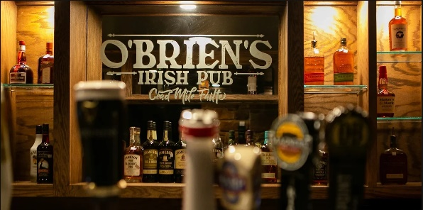

This is our 1Q pre-camping season luncheon (a change of pace from our typical Valentine’s Day Luncheon. Come and meet new club members and catch up on the doings of your old friends.
O'Brien's Home (obriensirishpubva.com) pub website

O'Brien's Lunch (obriensirishpubva.com) lunch menu

Note: vegetarian options are limited to Impossible Burger, soup and salad. But I imagine the chef might modify some other menu items to comply to your needs. You might give them a call if you have concerns.

M a r c h 2 9 - A p r i l 2 - Region 3
Region 3 Rally - Myrtle Beach, SC Region 3 Board hosting
Ocean Lakes Family Campground
6001 South Kings Hwy., Myrtle Beach, SC, 29575
Campground Reservations 877-510-1413

Come rally together with 100+ fellow Airstreams from the Southeast U.S. at this legendary beachside campground. Food, fun, dancing, games, workshops and MORE. Extended stays available. Information available on this link.
Region 3 2023 Rally | ACI (airstreamclub.org)

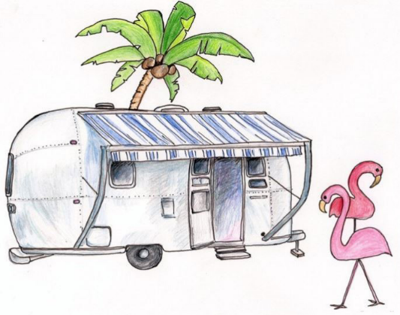

A p r i l 2 1 - 2 3 Northern Virginia Airstream Club (NORVA)

“Breakout” Maintenance Rally
Meadow Event Park,
13191 Dawn Blvd, Doswell, VA 23047
37.85242, -77.42380
Hosts: Barry Miller and Susan Haw

BETTER TO BREAKOUT THAN BREAKDOWN This Rally is traditionally called “breakout” because it comes at the beginning of the camping season. It is run by NORVA club and we will be their guests. Besides beautiful Spring camping, this rally focuses on learning how to maintain your Airstream (with an emphasis on the Travel Trailers). A great rally for new Airstreamers, but popular with all. Registration deadline is April 1. Camping fee $90, Rally fee $20. More details and registration link available at

Link to NORVA rally information

M a y 4 - 7

Cinco De Mayo Rally - Fort Valley Ranch - Bob & Lisa Sachs hosting
299 S. Fort Valley Rd., Fort Valley, VA 22652
38.75372, -78.51314

(540) 933-6633

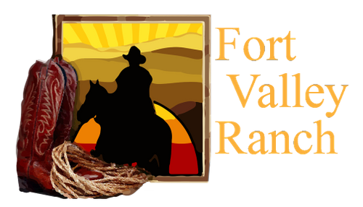

Back by popular demand, we’ll rally at Fort Valley in our lovely Shenandoah Valley. This time, leave your Stetsons at home and bring your Sombreros and Serapes, muchachas & muchachos (is that enough cultural appropriation for one sentence?)!! Hiking and horseback riding plus the usual fun and feasting.

More Information to follow. Minimal rally fee. Horseback riding is your option and at your expense.

M a y 1 5 - 1 8 - Virginia Club
Virginia Club Silver in the Streets Rally - Abingdon, VA

J u n e 2 4 - 3 0 - International Rally
66th International Rally - Rock Springs, WY
Sweetwater Event Complex - 3320 Yellowstone Road, Rock Springs, WY, 82901

Hopefully, you have secured your site for “The International” already. All 1200 sites have been reserved! There is a waiting list that you can get on. There will always be some cancellations as we get closer.

Here’s the link:
2023 International Rally Rock Springs, WY | ACI (airstreamclub.org)

A u g u s t 6 - 1 3
Galax Fiddlers National Event Rally –
Cool Breeze Campground –
2330 Edmonds Rd, Galax, VA 24333
36.56780, -80.94295

Christine and Joe Baum hosting
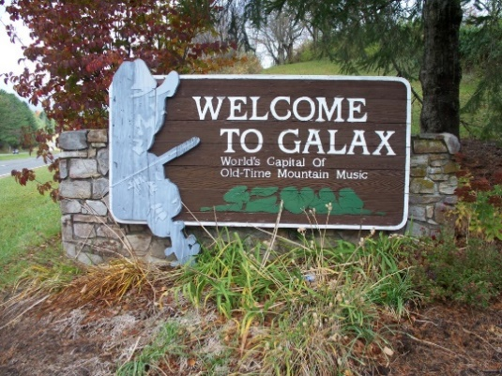
Rally with your fellow Airstreamers and join the 87th Annual Old-Time Fiddlers Convention in Galax VA. The convention features both youth and adult individual competition in old-time and bluegrass instruments (fiddle, banjo, dulcimer, mandolin, autoharp, guitar) as well as clogging, vocal and band competitions running nightly Monday through Saturday.

A truly great event of Americana music. The Airstream rally program also includes field trips, and opportunities for hiking, tubing, biking, and exploring the beautiful Blue Ridge parkway. Not to be missed.
Here’s the link:
Galax Old Fiddlers Rally | ACI (airstreamclub.org)

S e p t e m b e r 2 1 - 2 4 - NORVA Club
Commonwealth State Rally - New Market, VA - NORVA Club hosting
Endless Caverns RV Resort, 1800 Endless Caverns Road, New Market, VA, 22844

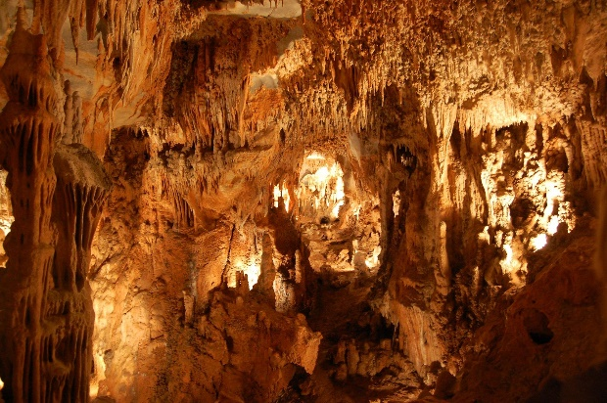
This year the Northern Virginia Airstream Club takes on the rotating leadership responsibility for the Commonwealth Rally [note: In 2024, it will be Spirit of Virginia Airstream Club’s turn to take the lead]

You can make your reservations now. NORVA has reserved 60 spots. Based on normal attendance, this should be enough. But, reserve early if you don’t want to get shut out.

Here’s the link:
2023 Commonwealth Rally | ACI (airstreamclub.org)

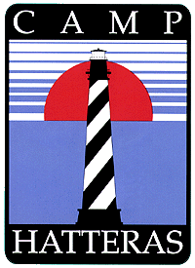
November 9 – 12
Grand Finale Rally – Rodanthe NC
Camp Hatteras RV Resort,
24798 Highway 12, Rodanthe NC 27968
35.58515, -75.46842

(252) 987-2777 jen@camphatteras.com

We will finish off the 2023 camping with our traditional rally on The Outer Banks. Camp Hatteras is keeping the fifteen best spots on the sound side available. These will be held from the general public until 60 days before the rally. Our camping fee includes the exclusive use of the beautiful clubhouse adjacent to these sites. We use the clubhouse for meals and events making the rally weatherproof!

Contact Jen Carlson at Camp Hatteras to reserve your spot:
$60/night Sound Front
$45/ night Sound Side

These prices can be extended for up to a 7 day stay if you wish to linger.

Link to Camp Hatteras RV Resort

