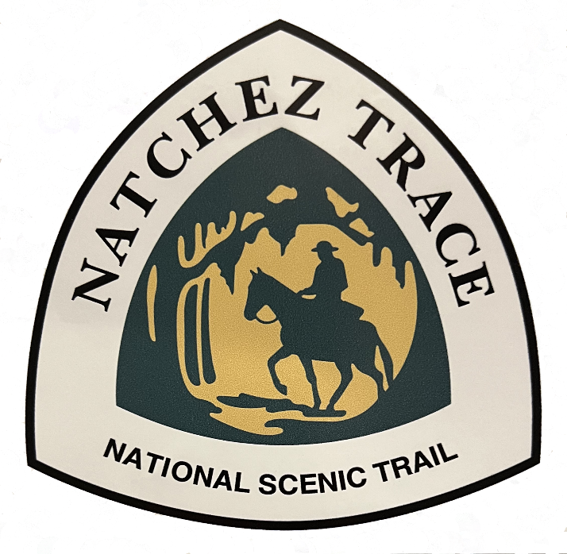

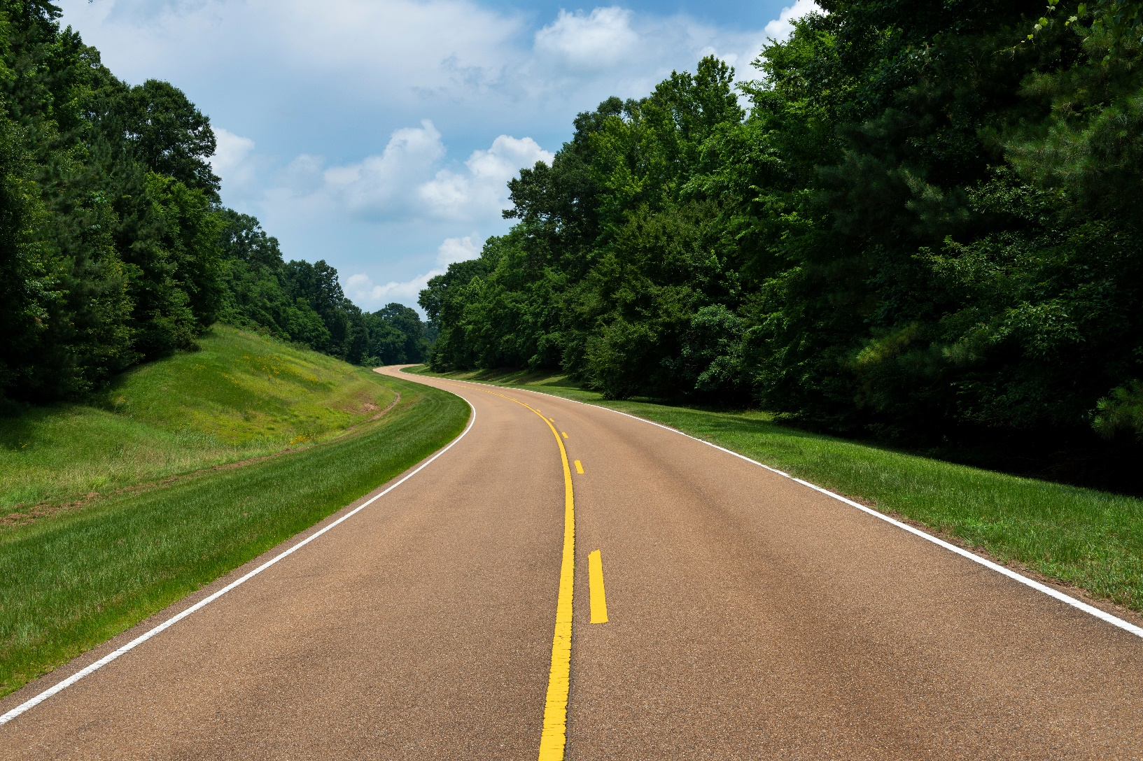Join us in 2025 and travel along the famed Natchez Trace from Natchez, MS to Nashville, TN!

A curvy two-lane road with no truck traffic, a relaxing cruise.

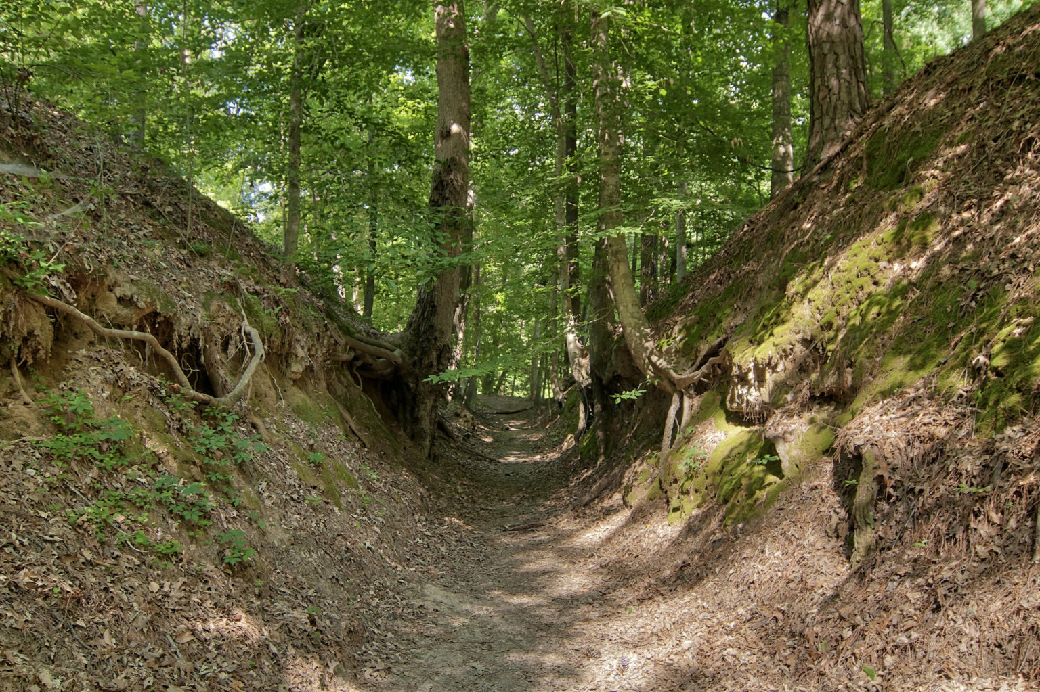Walk the actual path wildlife, settlers, boatmen, soldiers and settlers have been using for 10,000 years.

See Te-lah-ney’s wall. The largest un-mortered stack stone wall in the world!

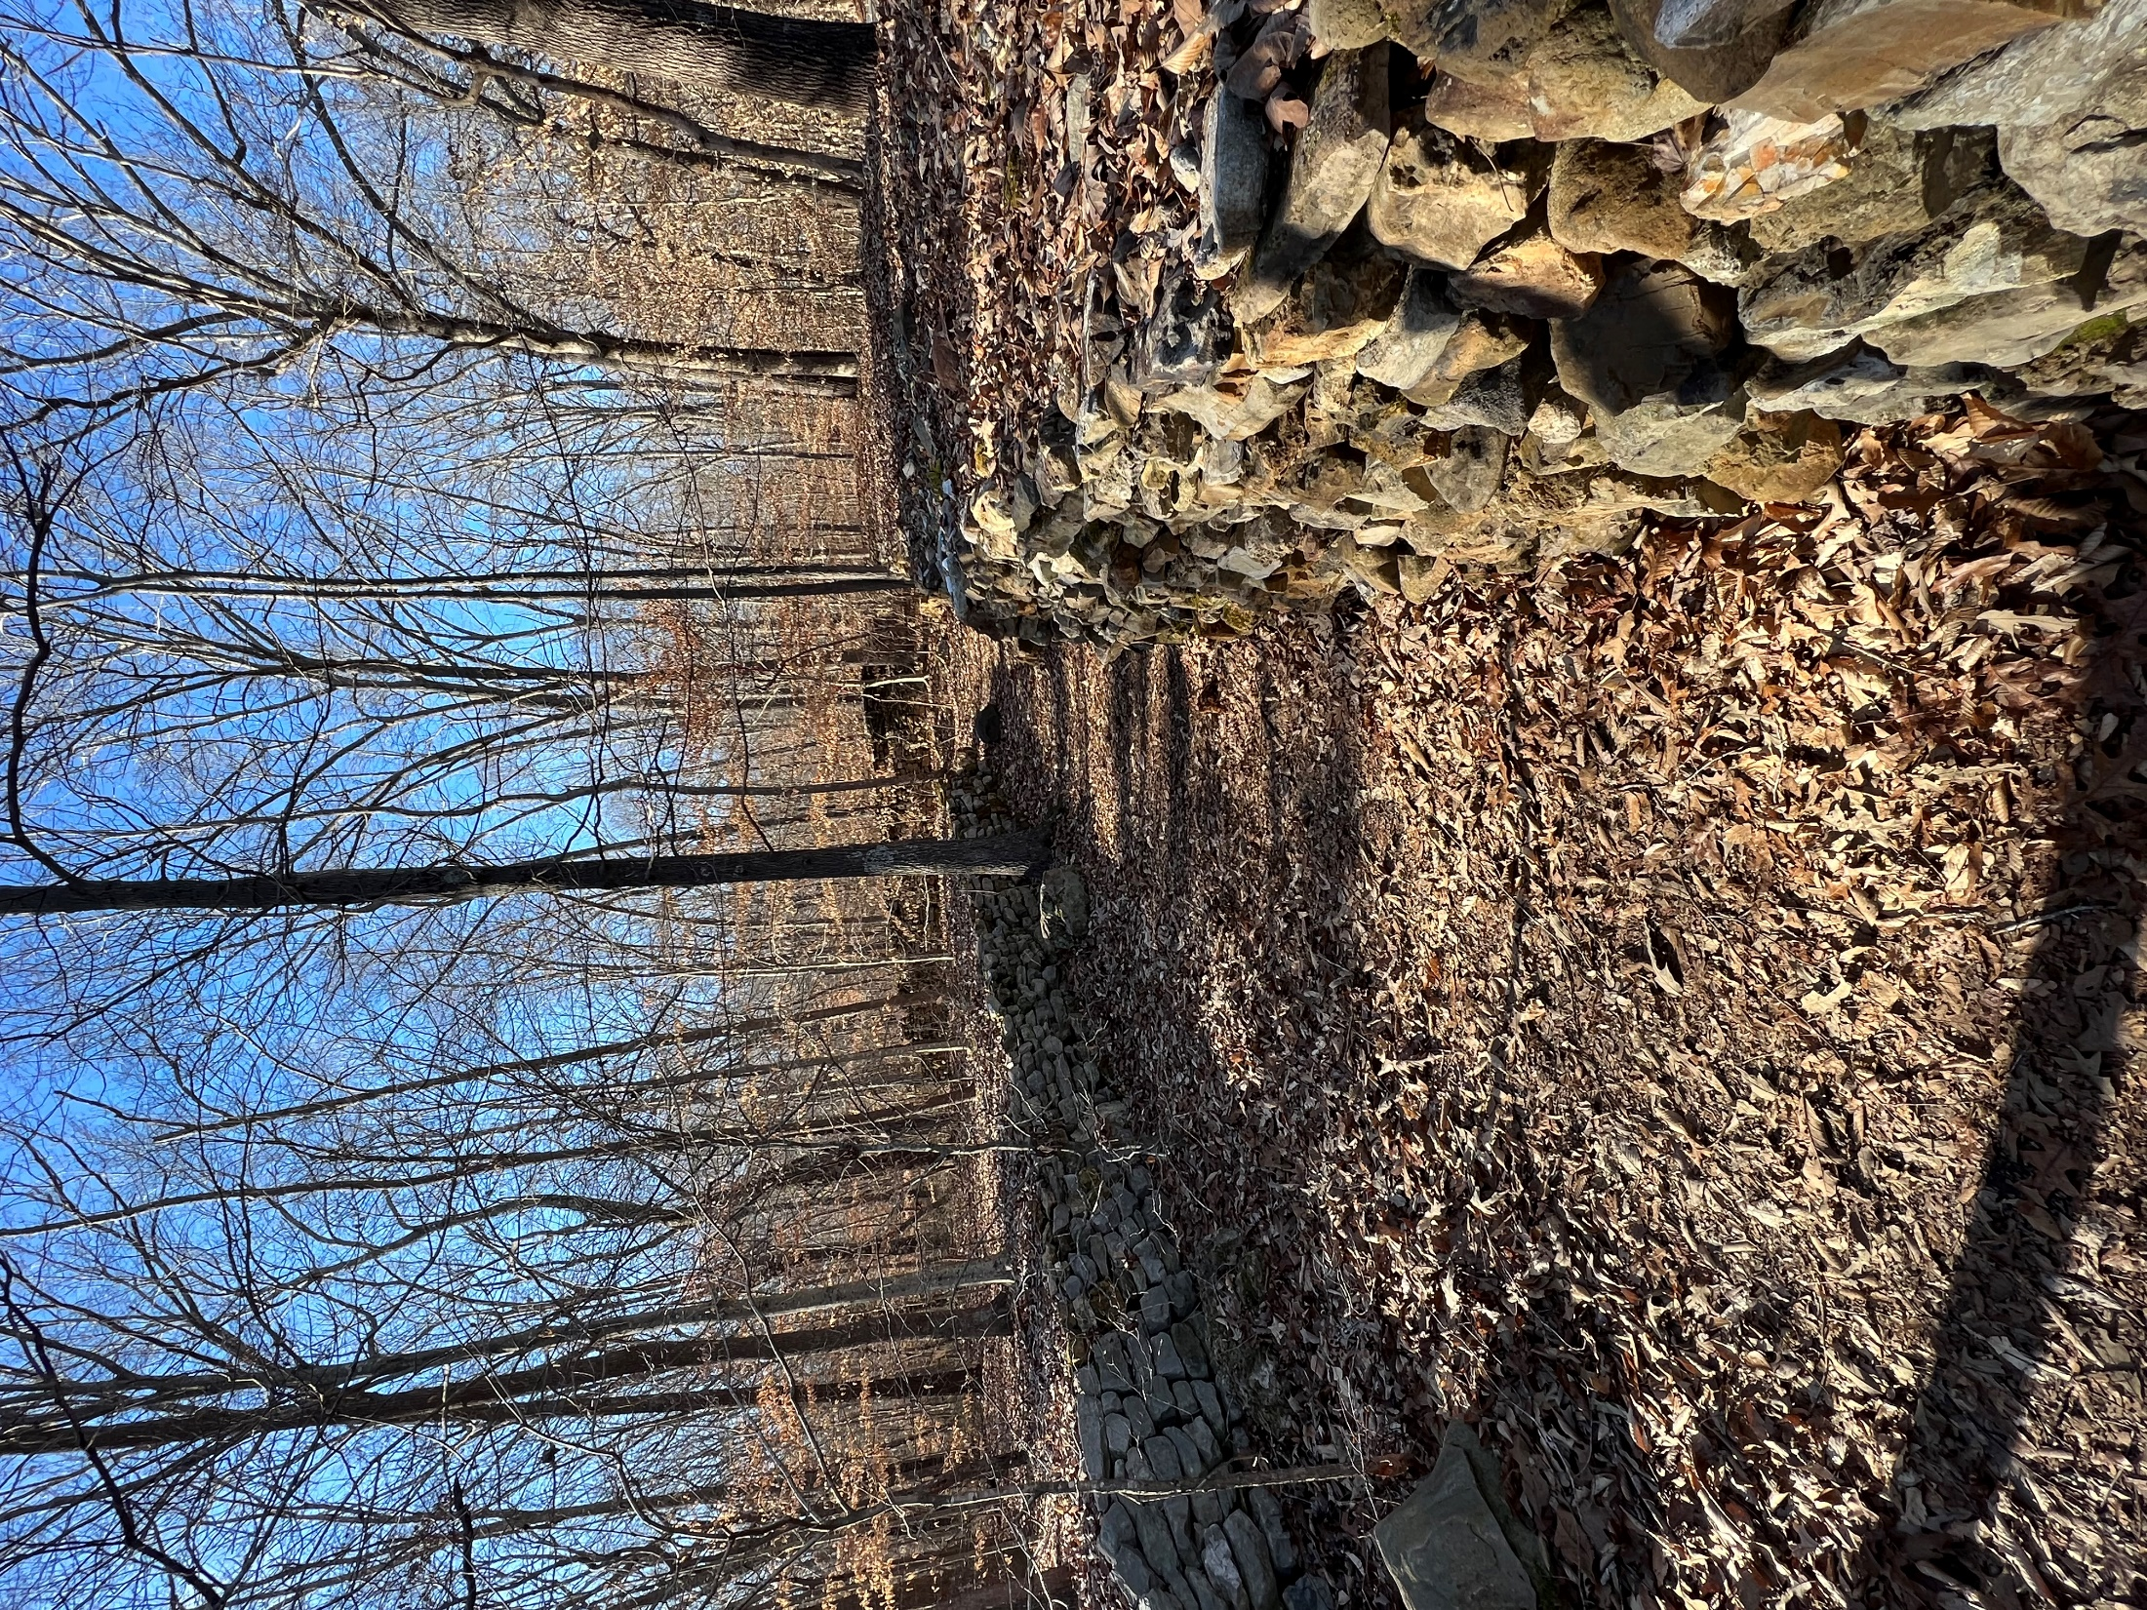

Party on Lower Broadway and at the Grand Ole Opry, in Nashville!



