Spirit of Virginia Events 2024 Rev 3/06
An Overview of Fun, Fellowship, and Learning

As with all things “calendar” related - Schedule subject to change. Stay turned.

An Overview of Fun, Fellowship, and Learning

Year Date Rally Location POC

2024 14-17 Mar Shamrock Ides Rally Misty Mountain Camp Janeene Rider
2024 5-7 Apr Maintenance Rally Urbana, VA, (dry camping) NORVA
2024 17-21 Apr Region 3 Rally Meadow Event Park Christine Baum
2024 3-5 May Cinco de Mayo Buddy Rally Fort Valley Ranch Bob Sachs
2024 31 May-2Jun {Sold Out} Sherando Rally Sherando Lake Jon Rathke/Joe Baum
2024 11-14 July Salute America Rally Pipestem Resort, WV Ken Tarrant
2024 4-11 Aug Fiddler’s Convention Cool Breeze, Galax, VA Christine Baum
2024 17 August Annual Club Meeting Rathke/Ottersberg Home Jon/Christine
2024 5-8 Sep Commonwealth Rally Madison Vines RV Resort Ken Tarrant
2024 5-11 Oct International Rally Sedalia, MO - It’s close; shall we Caravan out?
2024 4-6 Oct Warbirds Rally Pungo, VA , (dry camping) Nancy Lawn
2024 31 Oct-3 Nov Grand Finale Buddy Rally Camp Hatteras TBD
2024 14 Dec Annual Christmas Party TBD TBD

2024 14-17 Mar Shamrock Ides Rally
Janeene Rider Janeenerider@gmail.com 703-408-1936

56 Misty Mountain Rd, Greenwood, VA 22943
38.03969, -78.74004

$30/ea. Plus camping fee as Misty Mountain –
click link below to register.
Shamrock Ides JotForm Link

SHAMROCK IDES RALLY
Misty Mountain Camp Resort
March 14-17, 2024
Join us at the intersection of St. Patrick’s Day and the Ides of March. Festivities include a Roman Toga Party, Green Eggs & Ham Breakfast, and Corn Beef & Cabbage Dinner with Green Beer & Irish Whiskey. A “spirits” tasting event featuring local fare from area wineries, breweries and distilleries is also planned. And – you won’t want to miss the entertainment on Saturday evening, including Irish Bingo along with singing and dancing to music provided by Sound Solutions.
Reserve your spot now at Misty Mountain Camp Resort at 56 Misty Mountain Road in Greenwood, VA. Sites 1 through 25B have been set aside initially at a 10% discount for this Spirit of Virginia Airstream Rally. Several “V” sites are also being held for a short time to meet overflow demand, as needed. Call Misty Mountain today at (540) 456-6409 to reserve one of these full hook-up sites.
Once you’ve reserved your site, don’t forget to register for the rally and remit the rally fee by completing the online JotForm registration.

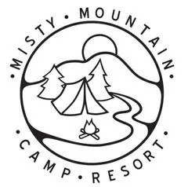
Click here to Register

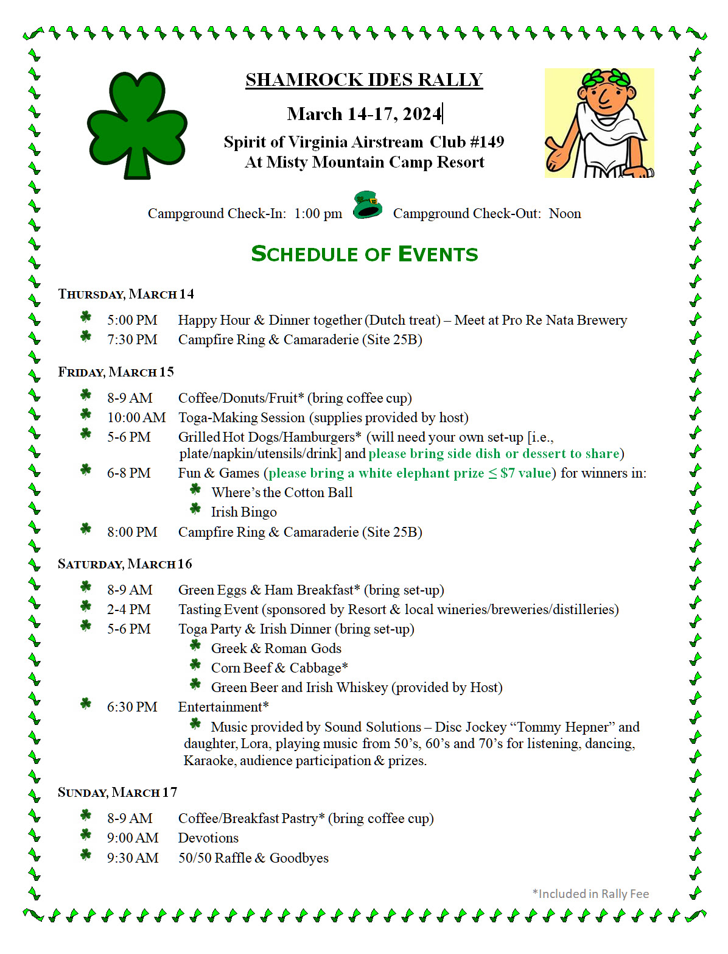

2024 5-7 Apr Maintenance Rally
NORVA
Urbana, VA, (dry camping)

Contact NORVA to register

Tom Carmichael, Rally Host
2212tjc@gmail.com

2024 17-21 Apr Region 3 Rally
Christine Baum baumjs@outlook.com 6092025015

Meadow Event Park, Doswell, VA

13191 Dawn Blvd, Doswell, VA 23047
37.85240, -77.42375

REGION 3 RALLY
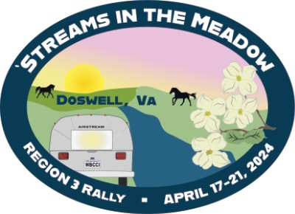
APRIL 17-21 - DOSWELL, VA
First Mate Joe Baum and I are excited about hosting our 2024 Region 3 Airstream Club rally at The Meadow Event Park at the State Fair of Virginia Fairgrounds in Doswell, Virginia. I am thrilled about our planned rally activities and enthusiastic to showcase and encourage visits to the nearby Richmond and Fredericksburg area historical sites. Above all, I’m ready for the fun of being together and enjoying each other’s company.

The Region 3 Executive Leadership Team, including 1st VP Bob Ealy, 2nd VP Bob Hoffman and I, have been busy planning an exciting agenda of live entertainment, vendor booths, seminars, happy hours, and of course meals. You will find opportunities for day trips to explore the history within the broader Richmond area and much more. We are calling this year’s Region 3 Airstream Club rally — ’Streams In The Meadow. Registration for the rally will include your camping reservation and rally fee, and can be completed by clicking the link below. Our preferred payment method is electronic (via Square), but we will also provide instructions to snail mail a check, if requested by you.
We welcome your attendance and participation at the ‘Streams In The Meadow rally. And, we will need your volunteer help to make the rally successful. Many hands make light work! You will have an opportunity to sign up to assist by completing the separate volunteer signup form(s) that we will make available in the next few weeks.
Click below for the rally registration form; deadline is Monday, April 1, 2024.
NOTE: All electric power at the rally will be 30-AMP; please bring an adapter, if needed. Additionally you may want to bring extra water hoses, sewer hose extensions and water hose Y- adapters. Camping includes water and electric. Please plan on arriving to the rally with empty gray and black tank. The Meadow Event Park facility does provide access to multiple dump station locations for your “blue-boy” portable sewer container (should you own one) for emptying throughout the rally.
We will periodically provide you with updates for the rally via email leading up to the event dates. Stay tuned for additional info about the detailed agenda.
All the best and see you down the road! Christine Baum, #257 & #4814
Click here to Register

Region 3 President

609.202.5015
Airstream Club International

2024 3-5 May Cinco de Mayo Rally
Bob Sachs safari27fbse@hotmail.com 202-577-5860
Fort Valley Ranch
299 S Fort Valley Rd, Fort Valley, VA 22652
38.75406, -78.51243

3-peat for the Spirit of Virginia Airstream Club Cinco De Mayo Rally
Fort Vally Ranch/Campground - Luray, VA May 3-6, 2024

Trail Rides in the Forest
For the third year, we will be having a Rally at Fort Vally Ranch/Campground near Luray the first weekend in May, hence the name "Cinco de Mayo". Official dates are May 3-6 and you are welcome to arrive on Thursday for an evening in Woodstock, VA. If you haven't been there yet, you have missed a treasure. It is a family owned campground nestled in the hills. A weekend there will provide you a relaxed event in a beautiful setting. If you are interested, the campground has guided trail rides into the George Washington National Forest.
Continuing the theme of repeats, on Thursday evening, we will go into Woodstock for dinner and liquid refreshments at the Woodstock Brewery.
We will have activities at the Campground around the Cinco de Mayo theme. If you want to venture outside of the campground, see the list below:
Near Bear Mountain Ziplining Minutes from Luray Caverns
Shenandoah River Outfitters located nearby for canoeing, tubing, and rafting

Near Luray Animal Sanctuary Zoo Close to scenic Skyline Drive Kennedy's Peak is minutes away
To reserve your spot, please call the campground directly and tell them you are with the Spirit of Virginia Airstream Club. 540-933-6633. Their website is: https://www. fortvalleystable.com/

We look forward to spending the weekend with you.

2024 31 May-2Jun {Sold Out} Sherando Rally
Jon Rathke jon.rathke@gmail.com 804-357-0333
Joe Baum baumjs@outlook.com 609-202-5015

Sherando Lake, VA
27 Ranger Ln, Natural Bridge Station, VA 24579
37.92145, -79.01806

2024 11-14 July Salute America Rally
TBD
Pipestem Resort, WV

3405 Pipestem Dr, Pipestem, WV 25979
37.53683, -80.99448

11-14 July - Salute America Rally Pipestem State Park, WV
Call WVa Parks at (833) 987-2757, saying you’re with the Rally
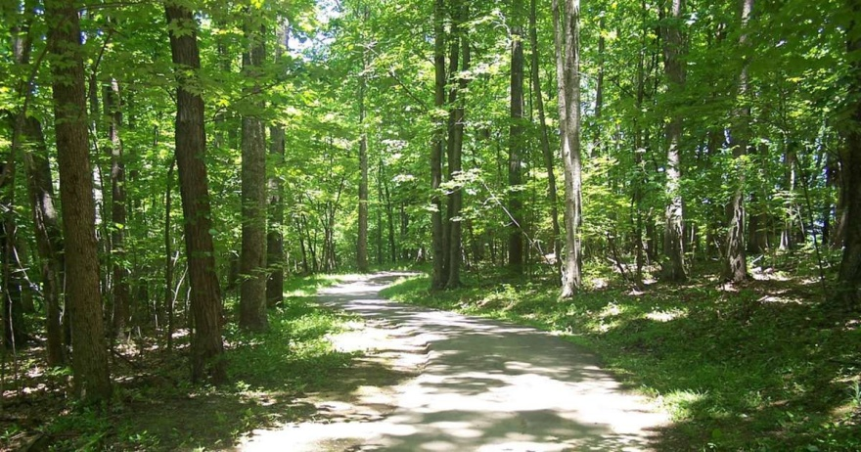
If you’ve been to Pipestem, then you’ve probably already registered. It’s neat!
There are Three (3) full hook up sites left in our HOLD. Don’t miss out.
The campground also offers a few electric/ water sites as well, but getting one during this PEAK season for camping will be a challenge.

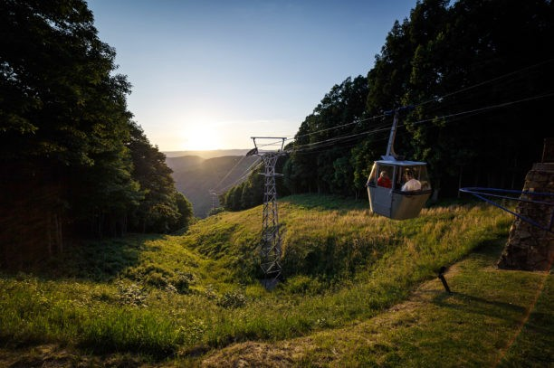
Many of us will take the Aerial Tramway over to the restaurant for a sumptuous meal one of the evenings we are there.
There is golf, disk golf, swimming pools, scenic hiking trails, and more.
10% Veterans Salute Discount Learn more at the Park Link below

Click the Park Link here

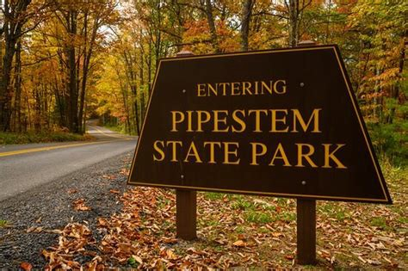
Click here to Register

2024 4-11 Aug Fiddler’s Convention
Christine Baum baumjs@outlook.com 609-202-5015

Cool Breeze, Galax, VA

2330 Edmonds Rd, Galax, VA 24333
36.56775, -80.94296

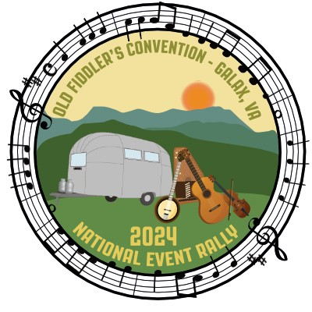
4-11 August - 88th Old Fiddler’s Convention - Galax, VA
Cool Breeze Campground

Do you love American Bluegrass & Old Time music? Wonder what the difference is?
This rally which originated as a Virginia Unit event decades ago, is sponsored by Region 3. We rally at
Cool Breeze Campground https://www.coolbreezecampground.com/ outside of Galax. The Convention is held at Felts Park in downtown Galax from the 5th to the 10th. But plan to check in at Cool Breeze on Sunday and depart on Sunday (7 nights). The campground is just off of the blue ridge parkway and lives up to its name (a plus in August!)
One stop shopping…. register for a site and the rally through campsite owner, Robert Sales at (276) 236-0300 or robert@coolbreezecampground.com .
The Convention activities happen in the evening (except the final day, Saturday, which is all afternoon and evening). Check out their website to view the schedule.
Daytime rally events include outdoor activities (hike, tubing, flatfoot dancing) and “field trips” to explore local history and Appalachian Music Culture. Most evenings we have on-site performances at the Campground around Happy Hour time. Plenty of free time to do what you do. Find out why so many Airstreamers come back year after year.
For more information, contact Rally Leaders (Spirit of Virginia’s Own) Christine Baum (609) 202 5015 or baumjc@gmail.com

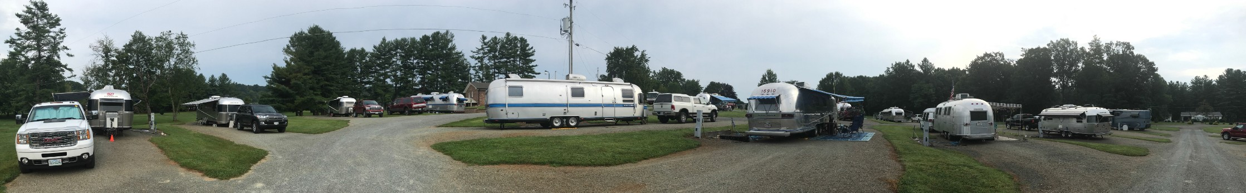

10-20 July - NORVA special offer ENDLESS SUMMER CARAVAN

OUR sister club is offering the few remaining spots for the NORVA 2024 Endless Summer Caravan! Embark on a summer journey along the picturesque US southeastern coast, spanning from North Carolina to Georgia. Don't miss out on this incredible opportunity!
Deposits are due immediately for these coveted spots. A deposit of $574 per trailer is required by February 28, 2024. Make check payable to James Oxley, 12706 Mill Glen Court, Clifton, VA 20124 and send via US mail. Second deposit of $633 is due April 1, 2024. Final deposit of $468 is due June 1, 2024.
Contact the Caravan Leader, James Oxley via email [oxley_j@msn.com] for more information.
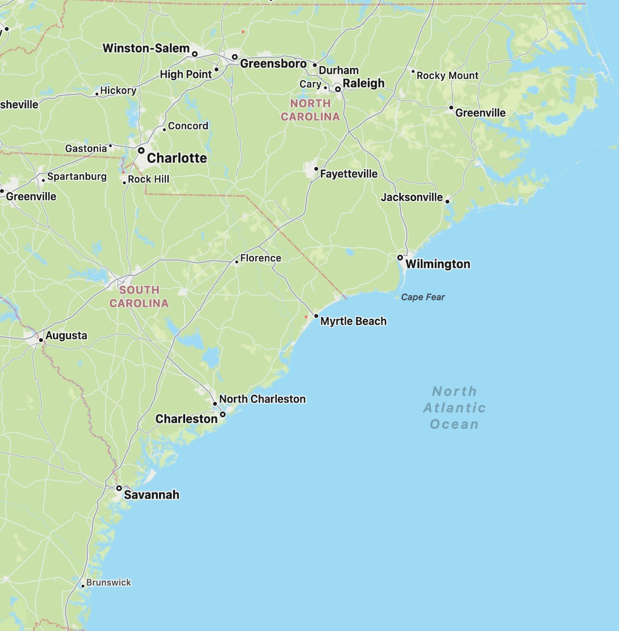

2024 17 August Annual Club Meeting
Jon\Christine jon.rathke@gmail.com 804-357-0333

Rathke\Ottersberg Home
Rhue Hollow Rd, Roseland, VA, 22967
37.74906, -78.97612

2024 5-8 Sep Commonwealth Rally

Madison Vines RV Resort, Madison, VA
110 Campground Ln, Madison, VA 22727
38.35353, -78.28142

It’s Our Year to host the Commonwealth - The Fun Group can Do It!

Ken Tarrant
kentarrant@comcast.net | 804-357-9977

5-8 September - All Virginia COMMONWEALTH RALLY
The members of the Spirit of Virginia Airstream Club are IN CHARGE of making the wonderful, annual Commonwealth Rally happen this year. We negotiated with MADISON VINES RV RESORT CAMP to hold sites for us! We’ve arranged for a short extension on the hold. Register Now.
To reserve a campsite with Madison Vines and receive the Rally Discount you must call in your reservation. Do Not use the on-line system. The numbers to call are the following:
Primary number—540-948-4186 — or — 540-407-0559, Jamie direct
When you call ask for Jamie McGuire (manager). Let her know that you are with the Airstream Group.

They assign campsites based on the length of your rig.

https://madisonvinesrvresortandcottages.com/

2024 5-11 Oct International Rally

Sedalia, MO –
It’s close; shall we Caravan out?
- Register at the ACI website - https://airstreamclub.org/rally2024

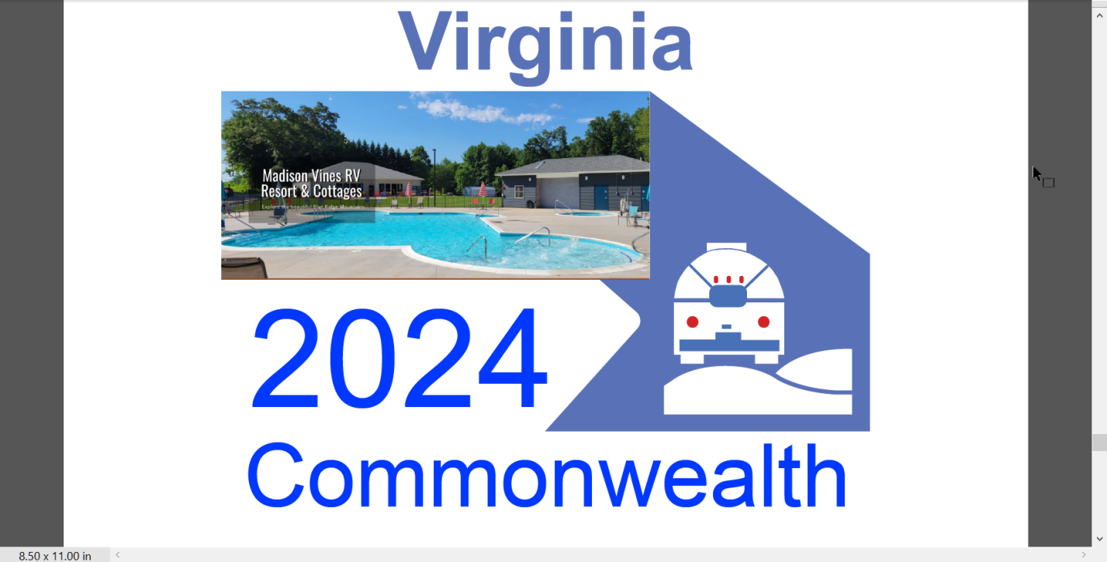

2024 4-6 Oct Warbirds Rally
Nancy Lawn thelawns@comcast.net 540-850-7599
Pungo, VA , (dry camping—private)
23456

36.72341,-76.01797

2024 31 Oct -3 Nov Grand Finale Buddy Rally
TBD
Camp Hatteras
, Rodanthe NC 27968

35.58515, -75.46842

