Arrival Instructions – Rally2024 Sedalia, MO

Arrival Options

NOTE: If you arrive before your registered park date, there is a $75 fee to park. Also, arrivals after 6 p.m. can stay in the staging area overnight with no hookups.

- General Arrival Area (GPS: 38.69017, -93.26509)
  - On your assigned or selected parking date.
  - Or Late Arrival after 6PM on the evening prior to your assigned or selected parking date.
- Off-Site Staging Area
  - For joining up with your group in advance of entering the rally area.
  - Thompson Hills Shopping Center
  - 890 Thompson Blvd, Sedalia, MO 65301
  - Roughly 1.2 miles north of the Arrival Area

Sedalia Fairgrounds Arrival Area
- GPS: 38.69017, -93.26509
- Drive along Clarendon Street, then right turn at “Gate 9” into the Arrivals Area.
- Approximately 0.5 miles south of the intersection of W. 16th Street and Clarendon Ave.
- Look for ACI Rally Signs
- Gate 9 at approximately 2401 Clarendon Rd, Sedalia, MO 65301
- Notes:
  - This is the ONLY advisable route to arrive.
  - Do NOT follow directions to the main Fairgrounds entry to the east.
  - As you head down Clarendon, go slow so you do not miss the right-hand turn into the Arrivals Area.

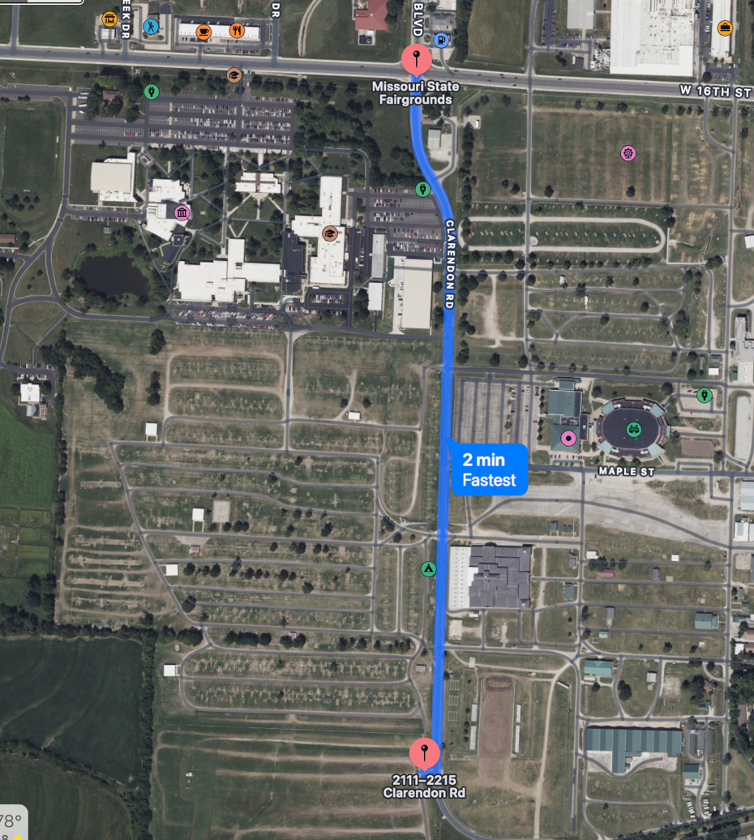

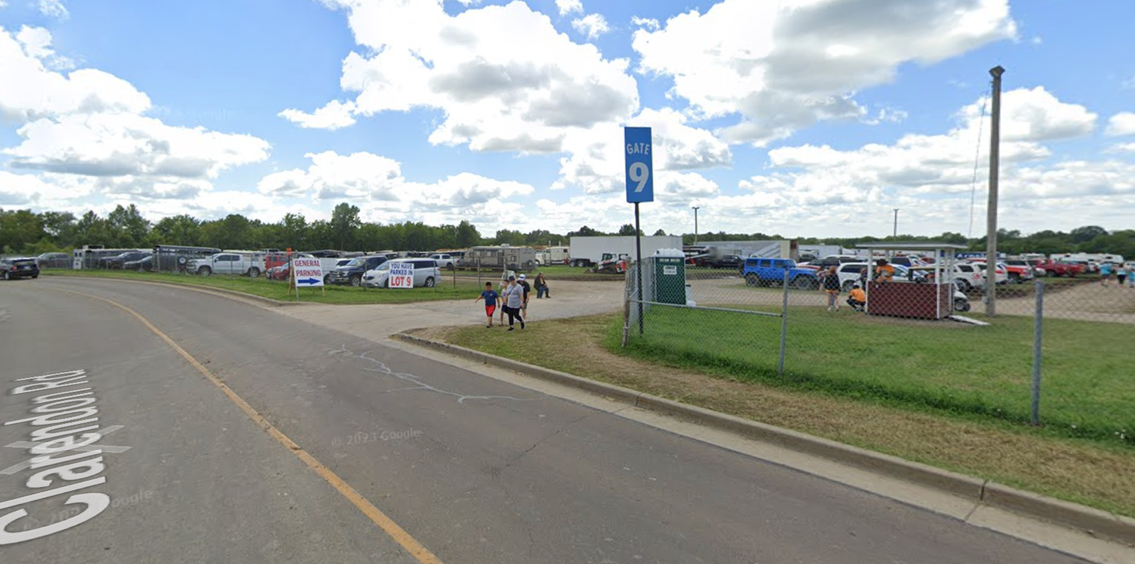

Staging Area
- For joining up with your group in advance of entering the rally area.
- Thompson Hills Shopping Center
- 890 Thompson Blvd, Sedalia, MO 65301
- Roughly 1.2 miles north of the Arrival Area
- Walmart is adjacent (to the west)

