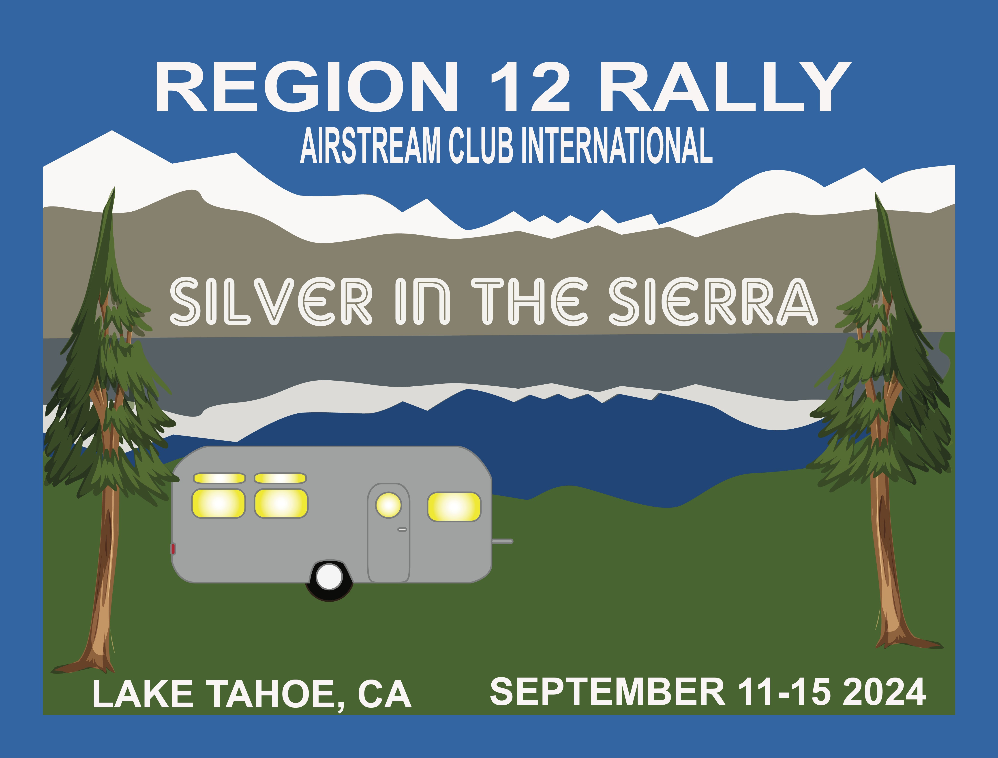

**REGION 12 BUSINESS MEETING**

**September 14, 2024**

1. Call to order
2. Officer Roll Call – Secretary, Margaret Handshoe to take roll
3. Minutes – Minutes from the December 2023 Business Meeting on Zoom are unavailable
4. National Anthem – introduce Bob Stansbury
   1. Welcome and Introductions
   2. Thank you to Region Rally Planning Committee
5. Treasurer’s Report – Teresa Tighe
6. Eric McHenry, ACI President
7. Policies
   1. Review changes to three policies (Cecelia, Teresa, Me):

i. Policy 2 – finances ii. Policy 3 – business meeting iii. Policy 4 – nominating committee

1. Nominating Committee
2. Club Report
   1. Central Coast California Airstream Club – Yvonne Savage
   2. El Camino Real Airstream Club – Lisa Anker
   3. Greater Bay Area Airstream Club – Eleanor McFarlin
   4. Greater Los Angeles Airstream Club – Michael Jackson
   5. Lake Tahoe Airstream Club – Cecelia Stansbury
   6. Las Vegas Airstream Club – Jo Salzer
   7. Northern California Airstream Club – Carmen Ortiz
   8. Sacramento Valley Airstream Club – James Goldstene
   9. San Diego Airstream Club – Pat Davison
   10. Sierra Nevada Unit – Brian Root
   11. South Coast California Airstream Club – Sharon Ticer

10)Correspondence

11) Membership Report

12)Discussion from the Floor