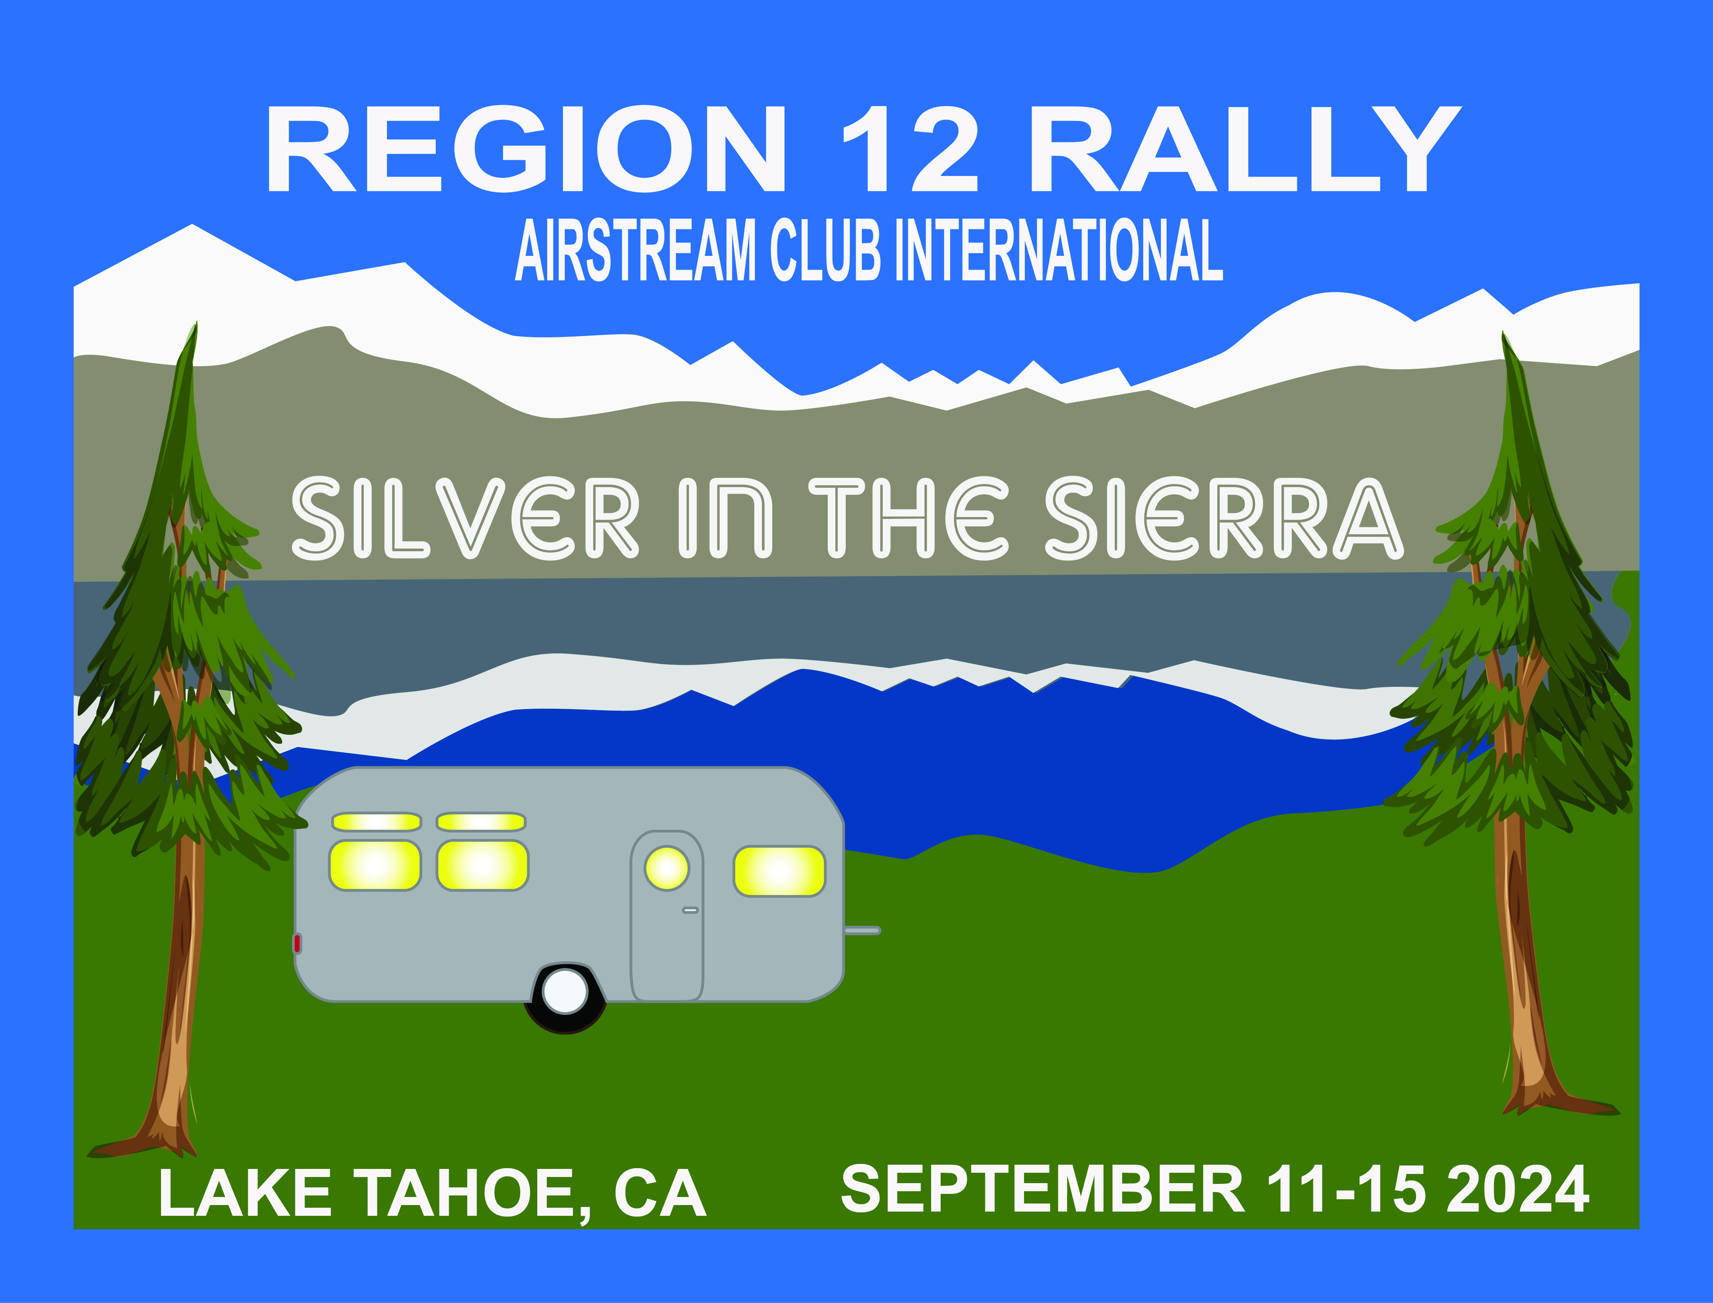

**REGION 12 RALLY**

**Wednesday, September 11**

12:00 Arrivals any time after noon

4:00 Yappy Hour (pet get together) location TBA

5:00 – 7:00 Non-hosted food truck on site near event tent

7:00 Ice-Cream Social, hosted by the Vintage Airstream Club *

**Thursday, September 12**

10:00 Hosted catered brunch *

10:15-10:30 Ice-breaker game with group *

10:45 Presentation by Lake Tahoe Wildlife Care (LTWC) *

11:30 Nature led walk by LTWC

5:00 Non-hosted Lake Tahoe Dinner Cruise

**Friday, September 13**

9:00 – 11:00 Vinnie’s Tech Talk (General Repair & Front End Separation)*

11:00 - 12:00       Vinnie’s Demonstration of AirSafe Hitch Installation—site E 392

1:00 —3:00           Vinnie’s Individual Consultation—prior sign-up required (see sign up in the tent)

1:00 – 3:00 Swap Meet and Craft Faire *

2:00 – 3:00 Craft Activity in same area $10 fee *

5:00 – 7:00 Silver Soiree happy hour appetizers @ Club-sponsored food stations. * Bring your own beverages if you wish.

5:00 – 6:30 Tour Ultimate Airstream Street of Dreams (near the event tent)

5:00 – 8:00 Live Music – Dennis Webber’s band – The Hip Replacements *

NOTE: Dinner on your own

**Saturday, September 14**

10:00 Region 12 Business Meeting *

11:00 – 12:30 Airstream Organizing, Decorating and Cooking *

5:00 Hosted, catered dinner *

6:00 Live Auction, Silent Auction winners announced *

7:00 – 9:00 Live Music, Antsy McClain and the Trailerpark Troubadours *

**Sunday, September 15**

Happy trails!

***See sign ups in the tent for yoga, bike rides etc.***

* indicates event takes place in the tent, located in the “Group Area”.