September 5-8, 2024 - Iowa North Rally

Pammel State Park

1900 Pammel Park Road, Winterset, IA 50273

Thursday, September 5, 2024

Please bring table service to all meals &

Campfire at each night

(weather permitting)

6:00 pm: Taco Bar provided

Please bring side or dessert to share  
  
  
Friday, September 6, 2024  
8:30 am: Crock Pot Breakfast Casserole, fruit provided  
  
10:00 am: line up - Rusty Stars Alpacas 2054 Rustic Ln, Winterset, IA: Free will donation

Lunch on own (ideas below) we can go as group or on own

* Pizza Hut has a lunch buffet 11-1; The Drift; Petite Café;

Hy-vee Market Grill & others  
  
4:00 pm: Installation of Officers

(White Shirt, red tie or neck scarf, dark pants for those being installed)

5:00 pm: Happier hour

6:00 pm: Grill your own meat on grills provided

Please bring side or dessert to share

Saturday, September 7, 2024  
8:30 am: Oatmeal & Ice Cream, fruit provided

Day to explore the area on your own:

-Madison County Farmer Market 8-12 located in Monument Park

(next to the Winterset Public Library)

-Clarke Tower

-Covered Bridges of Madison County

-Iowa quilt museum

-Antique shops

-Madison County Historical Museum (11-4) cost

-Spoons Full of Sugar Boutique

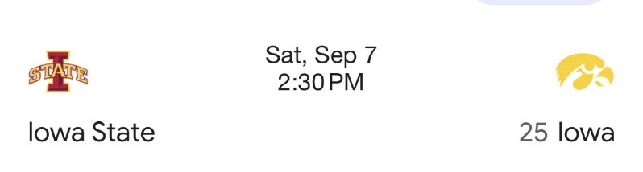-Frostee’s Ice Cream

2:30 pm: Iowa / Iowa State game   
 Tailgate – bring snacks to share

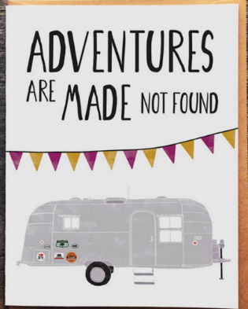6:00 pm: Grill your own meat on grills provided

Please bring side or dessert to share

Sunday, September 8, 2024   
8:30 am: Casey’s Breakfast Pizza

SEE YOU DOWN THE ROAD!