***Spirit of Virginia Grand Finale Rally 2024***

***Camp Hatteras, Rodanthe, NC***

**31 October thru 3 November 2024**

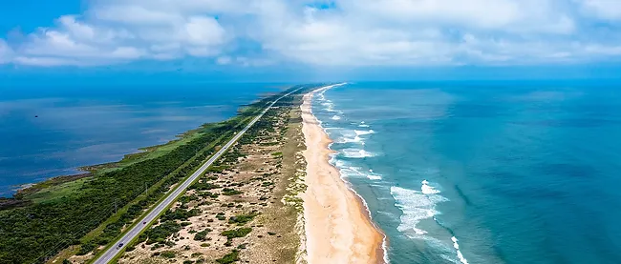

***Airstreamers,***

Welcome to the Grand Finale Rally!! We all are excited to spend another weekend at Camp Hatteras. As usual this Grand Finale Rally will be an intimate (10-12 rigs), laid back affair.

**A few notes:**

* The weather can be a bit unpredictable—wet or dry, cold or hot, windy or calm---so be prepared.
* Bring cash…OBX restaurants have some restrictive policies around splitting checks.
* If you have bikes, there are plenty of places to ride.
* From Kitty Hawk and the Wright Brothers (National Park) to Ocracoke Island there are plenty of things to see.
* If you are an angler, there is surf and piers to fish nearby.
* **IMPORTANT: The campground policy with respect to rallies states that we must maintain 10 paying sites to receive our discounted rate and have use of the Conference Center. Currently we have 10 reservations. If you know of anyone else who might attend, please reach out to them. This is a “Buddy Rally” so any friend, no matter the brand, can attend.**
* **Reservations: Call Jen Carlson, Rally Coordinator, Camp Hatteras Campground and Resort—252-987-2777 ext.105**
* **jen@camphatteras.com**
* **If you have any question please contact Ken Tarrant, Spirit of Virginia Airstream Club, 804-357-9977**
* **kentarrant@comcast.net**

|  |  |  |  |  |
| --- | --- | --- | --- | --- |
| **Rally** | **Schedule** |  |  |  |
| **Day** | **Date** | **time** | **Event** | **Location** |
| **Wednesday** | **30-Oct** | **all day** | **Rally team arrives** | **Camp Hatteras** |
|  |  |  |  |  |
| **Thursday** | **31-Oct** | **1:00 PM** | **Check-in Campground** | **Camp Hatteras Office** |
|  |  |  | **Pay Rally Fee--$25/rig--cash or check** | Site 387--Ken Tarrant |
|  |  |  |  |  |
|  |  | **5:00 PM -6:30 PM** | **Happy Hour ("Group Therapy")** | **Conference Center** |
|  |  |  | Bring finger foods\snacks to share--BYOB |  |
|  |  |  |  |  |
|  |  |  | **Dinner--on your own** |  |
|  |  |  |  |  |
| **Friday** | **1-Nov** | **8:30 AM-9:30 AM** | **Breakfast** | **Conference Center** |
|  |  |  | Bring set-ups and coffee cups |  |
|  |  |  |  |  |
|  |  | **6:00 PM** | **Group Potluck Dinner** | **Conference Center** |
|  |  |  | Bring your favorite casserole\ main dish to share |  |
|  |  |  | Bring set-ups and BYOB |  |
|  |  |  |  |  |
|  |  | **8:00 PM** | **Campfire** |  |
|  |  |  | (depending on weather\wind) | **campsite # TBD** |
|  |  |  | bring your chairs |  |
|  |  |  |  |  |
| **Saturday** | **2-Nov** | **8:30 AM-9:30 AM** | **Breakfast** | **Conference Center** |
|  |  |  | coffee, breads, yogurt and fruit |  |
|  |  |  | bring your set-ups |  |
|  |  |  | set-ups |  |
|  |  |  |  |  |
|  |  | **6:00 PM** | **Group Dinner** | **Good Winds Restaurant** |
|  |  |  |  | 240502 Hwy 12 |
|  |  |  |  | Waves Village Watersports Resort |
|  |  |  |  | Rodanthe, NC 27958 |
|  |  |  |  | (a block away from the campground) |
|  |  |  |  | bring cash--OBX bill policy for groups |
|  |  |  |  | are restrictive |
| **Sunday** | **3-Nov** | **8:30 AM** | **Coffee and Good byes** |  |
|  |  |  |  |  |
|  |  | **12:00 PM** | **Check out** |  |