***Spirit of Virginia Grand Final Rally 2024***

***Camp Hatteras, Rodanthe, NC***

**31 October thru 3 November 2024**

Airstreamers, come join us for our annual end of the season rally! The fall on the Outer Banks promises mild temperatures, sunny days and no crowds. Biking, fishing, shelling and shopping …what more could you need…oh yeah, there are those phenomenal sunsets!!!

Camp Hatteras is a wonderful facility. Our sites are right on the sound.

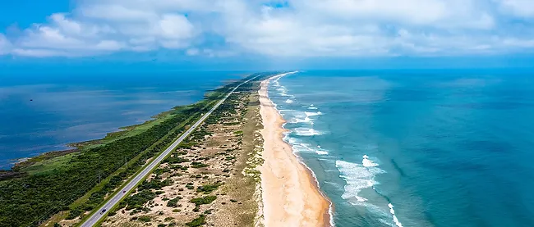

“Immerse yourself in the exclusive oceanfront-to-sound front camping experience at Camp Hatteras Campground and RV Resort, the only one of its kind in North Carolina.   Join us for a relaxing camping adventure at our family-owned campground, serving guests since 1991. With over 400 full hookup sites on concrete pads, you will have the ideal setting to park your RV or pitch your tent for an unforgettable stay.”

**Make your reservation today!!! Call Jen Carlson, Rally Coordinator, Camp Hatteras Campground and Resort—252-987-2777 ext.105**

**jen@camphatteras.com**

**You must reserve your campsite by 15 September 2024 to receive a rally discount.**

**If you have any question please contact Ken Tarrant, President Spirit of Virginia Airstream Club, 804-357-9977**

**kentarrant@comcast.net**