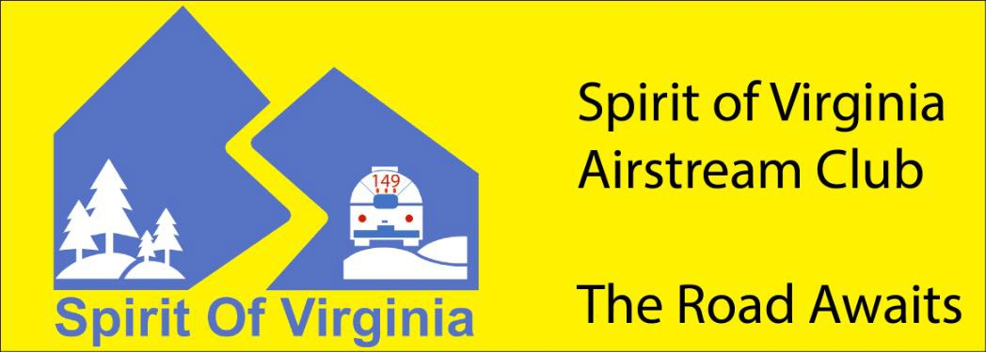
2025 Rallies & Events
Schedule
v.8
(11/24/24)

Year | Month | Date(s) | Rally/Event | Location | Point of Contact
2024 | Dec | 14 | Holiday Luncheon | Blue Ridge Café  Ruckersville, VA | Lisa Sachs  Lisalburg@hotmail.com
2025 | Jan | 1 | “First Day Hike” at America’s State Parks. Join other Airstreamers for New Year’s Day hike at:  - Cold Harbor Battlefield, Mechanicsburg, VA (led by Spirit of VA)  - Hungry Mother State Park, Marion (led by Virginia)  - First Landing State Park, Virginia Beach (led by Tidewater)  - Mason Neck State Park, Lorton (led by NORVA) |  | Lisa Lichenstein  LisaLichtenst3@gmail.com  Note location change!
2025 | Jan | 18 | Planning Meeting: 2026 (Rallies/Events Straw-man Schedule) | Location TBD | TBD
2025 | Feb | 22 | >>> CANCELLED <<<  Valentine’s Luncheon | Hotel 24 South  Staunton, VA | Greg Heuer  gheuer@umich.edu
2025 | Feb | 20-23 | Staunton Staycation | Frederick House B&B  Staunton, VA | Greg Heuer  gheuer@umich.edu
2025 | Mar | 13-16 | Itchin’ to Hitch Rally | Belle Isle State Park  Lancaster, VA | Jon Rathke / Ron Raymond  Jon.rathke@gmail.com
2025 | Apr | TBD | Mosey to Charleston | Caravan to Region 3 “2025 Rally” | Ron Raymond  raymondrc@earthlink.net
2025 | Apr | 9-13 | Region 3 “2025 Rally” | Exchange Park Fairgrounds  Charleston, SC | Wayne Clark  wclark@airstreamclub.org
2025 | May | 2-4 | Rally Theme Dark Sky | James River State Park  Gladstone, VA | Bob Sachs  Safari27fbse@hotmail.com
2025 | May | 8-18 | Chesapeake Adventure Caravan | Maryland/Virginia Eastern Shore | Greg Heuer  gheuer@umich.edu
2025 | June | 13-15 | Rally Theme TBD  Note date change! | Chippokes Plantation State Park, Surry, VA | Joe Baum  Baumjs@outlook.com
2025 | July | 4-7 | Co-rally with all 4 VA clubs for “Up, Up, and Away” Rally (at Balloons Over Rockbridge Festival) | Virginia Horse Center  Lexington, VA | Balloon festival rally led by Virginia Airstream Club with support from other 3 VA clubs.
2025 | Aug | 4-9 | Old Fiddler’s Convention | Cool Breeze Campground  Galax, VA | Christine Baum  baumjc@gmail.com
2025 | Aug | 16 | Spirit of VA Annual Club Meeting & Election of Officers | Rue Verde Hacienda  Roseland, VA | Jon Rathke  Jon.rathke@gmail.com
2025 | Aug | TBD | Virginia Commonwealth Caravan to York | (All 4 VA clubs discussing caravanning together to International Rally) | (will advise)
2025 | Aug | 23 – 28 | Airstream 68th International Rally* | York Expo Center  York, PA | Airstream Club Int’l  rally@airstreamclub.org
2025 | Sept | 26-28 | Virginia Commonwealth Rally | American Heritage RV Park  Williamsburg, VA | Tidewater Club
2025 | Oct | 17-19 | Rally Theme TBD  Possible co-rally with Tidewater Club (and potentially the West VA unit) | Douthat State Park  Whispering Pines CG  Millboro, VA | Bowmans / Regans  devinbowman@juno.com
2025 | Oct | 23-26 | Alumalina* | Tom Johnson’s Camping Work Rally Park  Marion, NC | John Leake  john@leakesantiques.com
2025 | Nov | 7-9 | Rally Theme TBD | North Landing Beach CG  Virginia Beach, VA | Ken Tarrant  Kentarrant@comcast.net
2025 | Dec | TBD | Holiday Luncheon (2025) | Casa Bowman | Devin & Jill Bowman  devinbowman@juno.com

*Included for planning purposes (to avoid scheduling conflicts)

For schedule updates, please visit: Spirit of Virginia Events | ACI (airstreamclub.org)
https://airstreamclub.org/spirit-of-virginia/spirit-virginia-events

