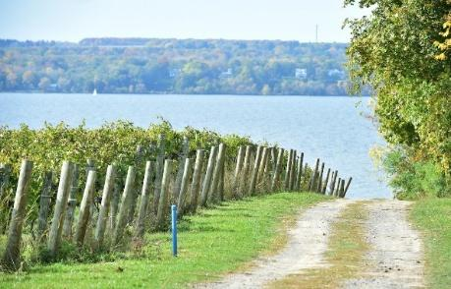
June 3-7, 2026
Linger in the Finger Lakes
with your NOVA friends
Register by October 23, 2025

Bring your rig to the enchanting Finger Lakes region of New York. If you haven’t explored the area, it’s known for beautiful scenery, significant history, and internationally known wineries. Rally at Watkins Glen State Park at the foot of Seneca Lake and join the festivities.
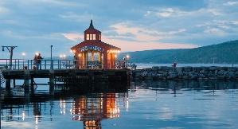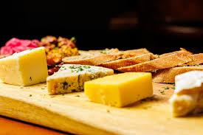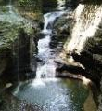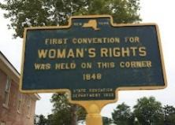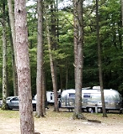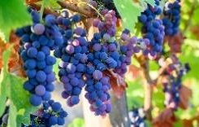
- Gather at the Finger Lakes Welcome Center in Geneva on Thursday
- Enjoy tastes and tours at wineries
- Visit history at the National Women’s Rights Museum in Seneca Falls, Glenn Curtiss Museum in Hammondsport and other sites
- Browse farmer’s markets
- Sample local cheeses
- Shop in the lovely towns of Watkins Glen and Hammondsport
- Hike the waterfalls at Watkins Glen and other regional falls
- Cruise along Seneca Lake
- Share your experiences (and tastes) at Saturday dinner in the campground shelter
Your registration is due by October 23, payment by October 30. Registrations are limited to 15 rigs, first come, first served. A waiting list will be formed after that. We need registrations early so you can get a campsite before the state park opens reservations to the public.
When we receive your paid registration, you will get a unique personal code and instructions to reserve your campsite between November 3 and 15. You are responsible for paying Watkins Glen for your site. Sites have 30/50-amp power. There is no water or sewer at the sites but water is available in the campground loop and there is a dump station.
Fees: $25 per unit, $50 per person (not including campsite) includes the welcome gathering at Finger Lakes Welcome Center, shelter rentals, supplies, and other goodies. Pay separately for campsites and expenses (admission tickets, tastings, and the Saturday dinner at the shelter).
Cancellation and alcohol policies are noted on your registration and invoice.
Questions? Contact Jim Naramore at info.CampNOVA@gmail.com

