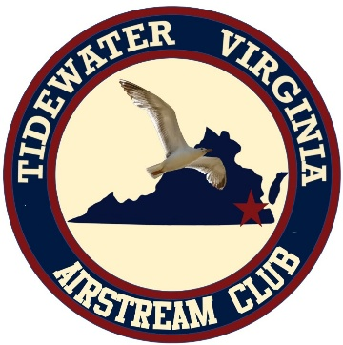
Tidewater Airstream Club
April 17-19, 2026 Rally

Kiptopeke State Park
3540 Kiptopeke Drive
Cape Charles, VA 23310
757-331-2267

Hosted by John and Lynette Patterson

Friday Happy Hour starts at 5pm.
BYOB and munchie to share

Saturday morning- Hike at 9am
Saturday Dinner at The Cape Charles Brewing Company

Sunday- Breakfast provided

Make Reservations now at 1-800-933-PARK or online at reservevaparks.com

Questions email John:
email - shoreriderses@gmail.com
Text - 757-710-3092.

Please text or email to let us know you are attending!!

