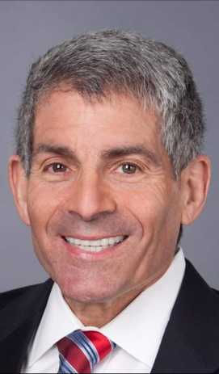 | PRESIDENT:  Glenn Stevens  President.GLAAC@gmail.com
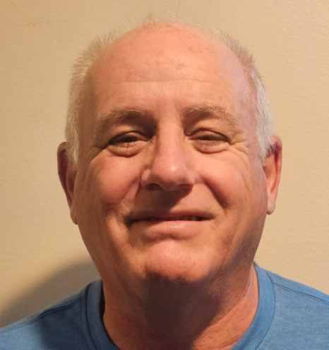 | 1st VICE PRESIDENT:  Charles Andrews  Greaterlosangelesairstreamclub@gmail.com
2nd VICE PRESIDENT:

Greaterlosangelesairstreamclub@gmail.com

TREASURER:
Dan Watts

Greaterlosangelesairstreamclub@gmail.com
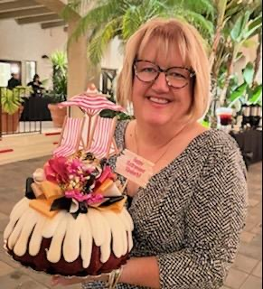 | SECRETARY:  Kimberly Brink  Greaterlosangelesairstreamclub@gmail.com
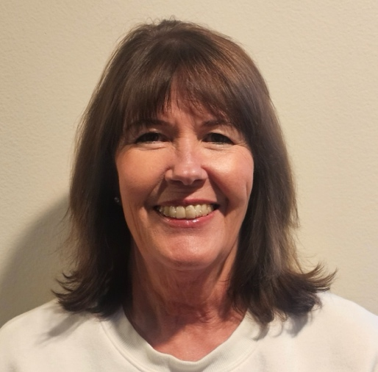 | MEMBERSHIP CHAIR:  Alicia Andrews  alicia768@att.com
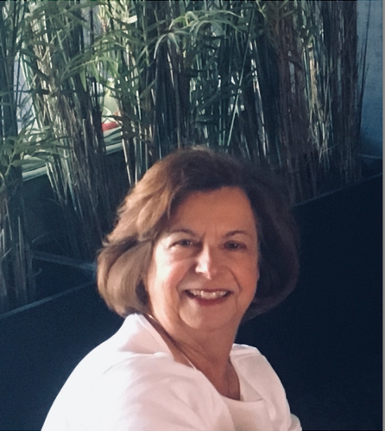 | EVENT CO-CHAIR:  Marion Kuhns  Events.GLAAC@gmail.com
 | EVENT CO-CHAIR:  Mira Zimet  Events.GLAAC@gmail.com
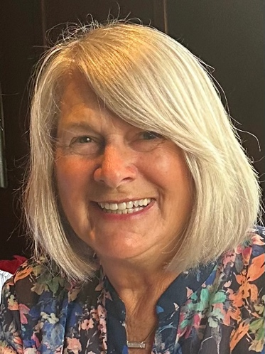 | NEWSLETTER EDITOR:  Lynda Polk  Newsletter.GLAAC@gmail.com
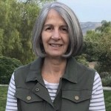 | WEBMASTER:  Paula Hammer  Greaterlosangelesairstreamclub@gmail.com
 | SOCIAL MEDIA CHAIR:  Lauretta Smith  Greaterlosangelesairstreamclub@gmail.com

