FLAG DAY RALLY

Belle Isle State Park
June 12 - 14, 2026

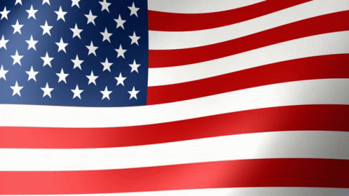

Make reservations NOW!!!
Don't miss out on this soon to be famous event. Only a few sites open.

If you are coming to the rally and your name is not on the list below, let Jack and Jean Hogan know and your site #.
Reservations we know of so far:
Site #12 Jack & Jean Hogan
Site # 8 Kelly & Kathleen Holschuh
Site #10 Kerry & Renée May
Site #11 Bill Bell & Ann Rutledge
Site #14 John & Sherry Woods
Site #17 Hap & Ruth Chester
Site #19 Jim & Nancy Corliss
Site #22 Jon Rathke & Christine Ottersburg

For new folks, dates are such that you arrive Fri., July12 and depart Sun., July 14.
For everyone, we added a day before and after for us. (you should too)

Activities:
Fun adventure awaits.
Details to follow closer to the time.

See you down the road.

Jack and Jean Hogan
jandjhogan@aol.com
Jack 757-472-0855
Jean 757-472-0857

